Vimukthi Vidya Samsthe-Chitradurga
Annual Report for the year April 2021 to March 2022

Project-1- Mensen met een Missie- Netherlands
Project-2- Open Hands India-UK

Dhamma
NH-48, Davangere Road, MK Hatti post
Chitradurga-577502
Cell-9902752205 and 9945716157

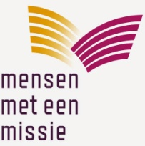
Annual Report 2021-22

- Basic information

Title of the project | Peace and reconciliation through interfaith approach
Project Number | IN210139
Period of report | 1st April 2021 to March 2022
Name of the organisation | Vimukthi Vidya Samsthe
Written by | Vishwa Sagar.R
Date | 15.04.2022

- Please describe major changes, if any (in the socio-political context and/or in your organization/staff that have affected the project implementation.

- There has been increase in participation in Communal harmony meetings/seminars and celebration of solidarity festival.
- Women Self Help groups which were engaged in financial and economic issues are now have started talking about communal harmony and peace promotion.
- There has been very good response from children and youth for communal harmony through participation in sports, cultural show, folk art, debate
- Dalith, Tribal, Nomadic and Muslim leaders are showing commitment for coming together and prevent communal tensions, conflicts in the area.
- Our entire team, Volunteers, leaders from women and Children group are committed themselves for Religious and communal harmony.
- New songs, audio-video, folk art, peace promotion pamphlets and other useful and effective peace promotion education materials (IEC) have been produced by the organisation and these are effectively used in creating awareness on peace.
- Due to continued struggles and campaign in peaceful manner, the nomadic families in two villages who never had proper housing and sanitation, have been allotted land and layout and levelling of land has been began at the cost of government, with investing about 10 million Indian money to begin.

- Please summarise the project activities implemented during the reporting period (with the major differences between the planned and implemented activities, if any).

Activities planned | Actual activities implemented
1. Motivation and training to volunteers (peace inspirers) on conflict resolution and interfaith peace | 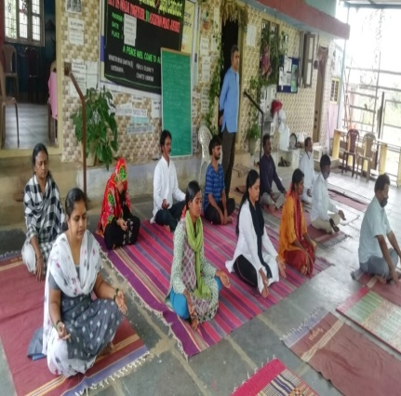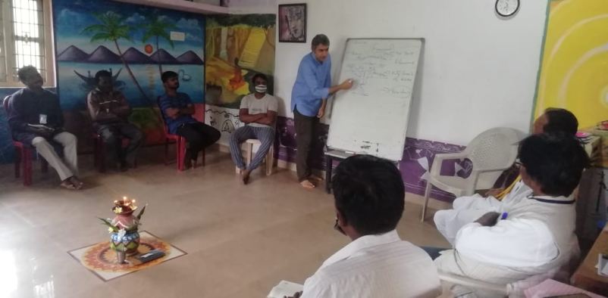  On 27.06.2021 Mr. Sharath Krishnan, the resource person training on functioning of body and mind, how our own thinking and reasoning is responsible for promotion of peace or creating tension, hate, violence. Further, he introduced contemplation process to control all negative thoughts and ill acts, within.  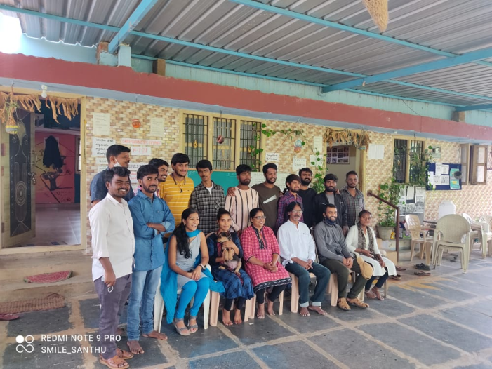  One day session was conducted on 26.7.2021 for the state level youth belong to Karnataka Vidyarthi Sangatane (KVS), Bangalore on role of youth in promotion of peace and counter the communal tension at local and state level. The orientation was held on at Dhamma campus.  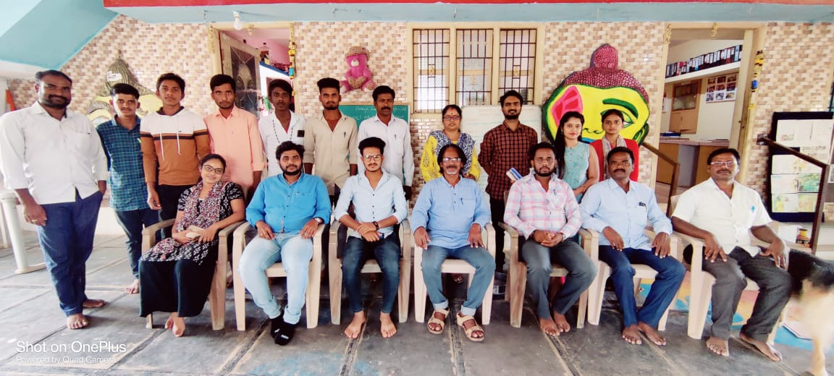  Above and below: On 18.3.2022, a one day orientation on Agendas behind Russia-Ukraine war, Karnataka Anti conversion Bill, Hijab issues was conducted at Dhamma. Mr. Sarovar facilitated the orientation as resource person. Students and Youth from Arali NGO, community, Vimukthi had participated.  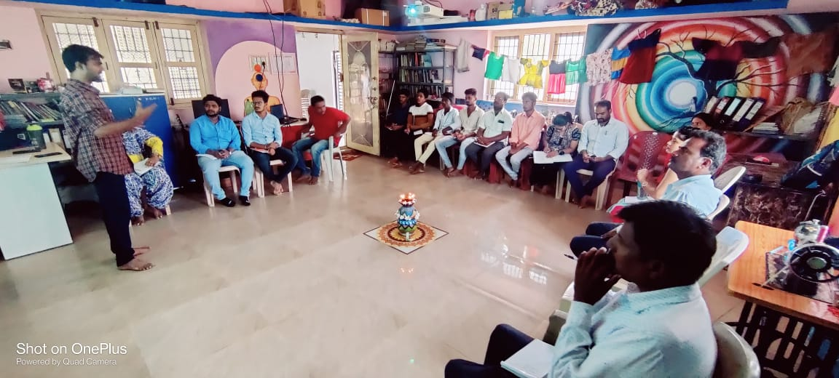
2. Peace education in schools, colleges and community using video shows. Debate competitions, discussions | 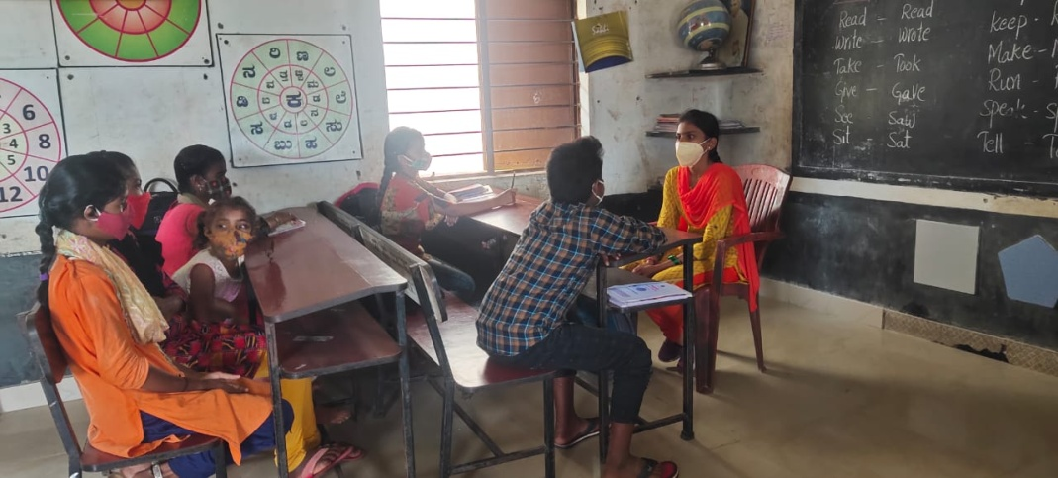  Volunteer Arpitha teaching children on peace education at government Primary school , MR Nagara in 4th week of October 2021  On 12.8.2021, on the eve of Independence day young girls/college students were encouraged to participate in inter religious sports and cultural competition like skipping and Rangoli. About 20 girls belong to Hindhu and Muslim community took part and enjoyed the event. As token of appreciation, all girls were given ration kit (nutritious) on 15.8.2021, at Government school, MR Nagara and talks were made by Mrs. Annapurna and on communal solidarity.  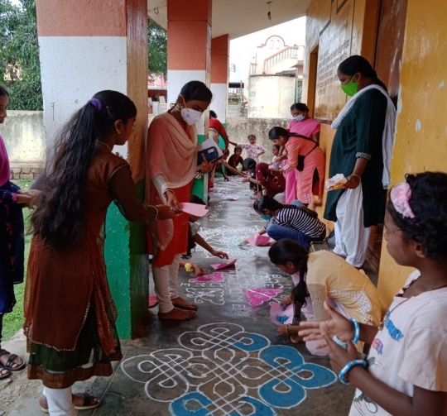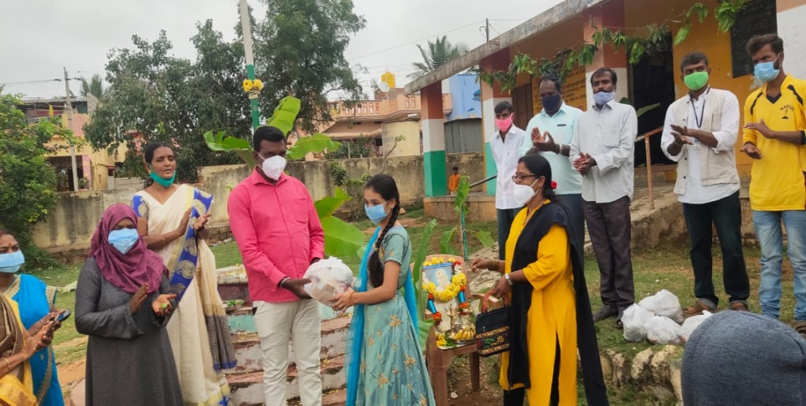  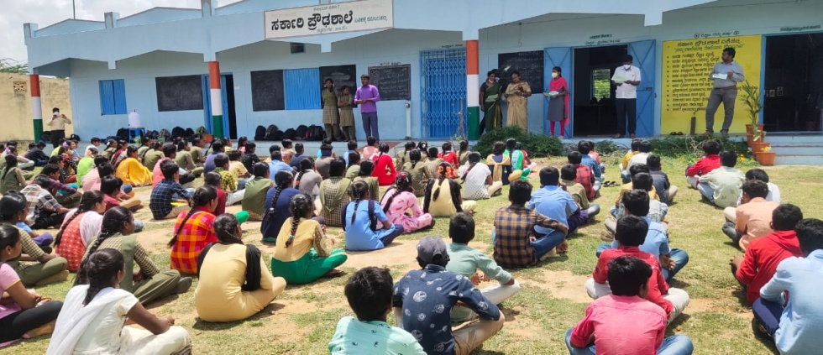  Awareness on communal harmony, through video show and pamphlets were conducted in 7 schools. About 50 to 150 children, both in higher primary and High schools were conducted by Kumar T, Gururaj, Arnya Sagar and Arpitha from 25th to 27th October 2021.  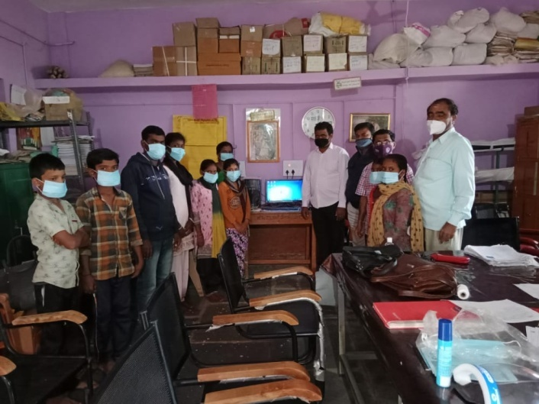  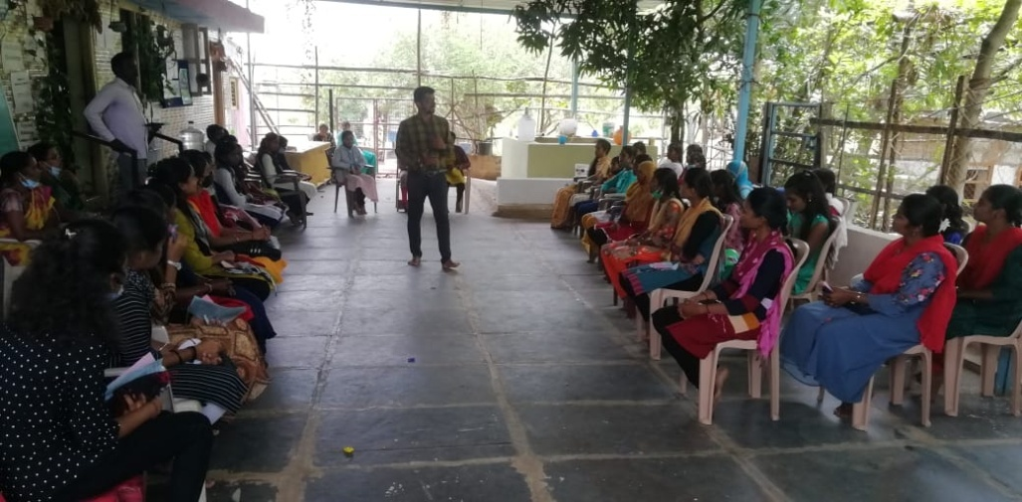  One 14.07.2021 one day orientation was for college and High school students were conducted at Dhamma. About 40 students from 8 villages had participated. Mr. Gagendra Naik , external resource person and Mr. Vishwa Sagar.R Facilitated the session using innovative exercises, games and video show.  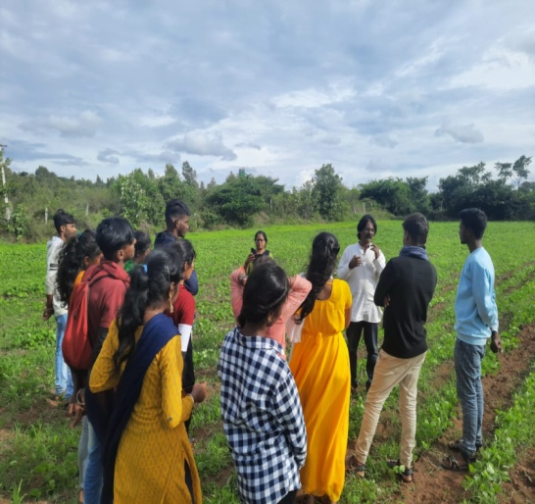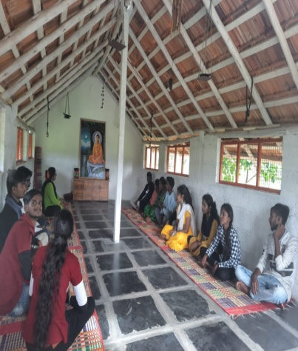  One day orientation sessions was conducted for Bachelor of Social Work (BSW), students from Tumkur University on On 5.9.2021 on social work and on Communal harmony .About 15 students and 3 faculty had participated.
  Date | Activity | Participants
  29.10.21 | Debat4 and video show | 124 students, teachers, H HM of Government High school, Nallur, Davangere district
  30.10.21 | Debat4and video show | 121 students, teachers, HM of Government High school, Basavapattana village, Davangere district
  26.11.2021 | Video show and debate | 43 MSW students for Davangere university on communal harmony and peace Volunteers
  17.11.21 | Video show, pamphlets distribution | 120 students, teachers of Lakshmisagar and Vijapur government high school,
  19.12.21 | Group discussion, video show, | 55 students from 5 villages, held at Dhamma
  28.12.2021 | Group games, video show | 23 students and adults from 3 slums of Chitradurga city.
3. Convention of exchange of adivasi, Nomadics and Muslim art and culture at district level | Convention of exchange of adivasi, Nomadics and Muslim art and culture at district level, preparation was done in October and it was held on 01.11.2021  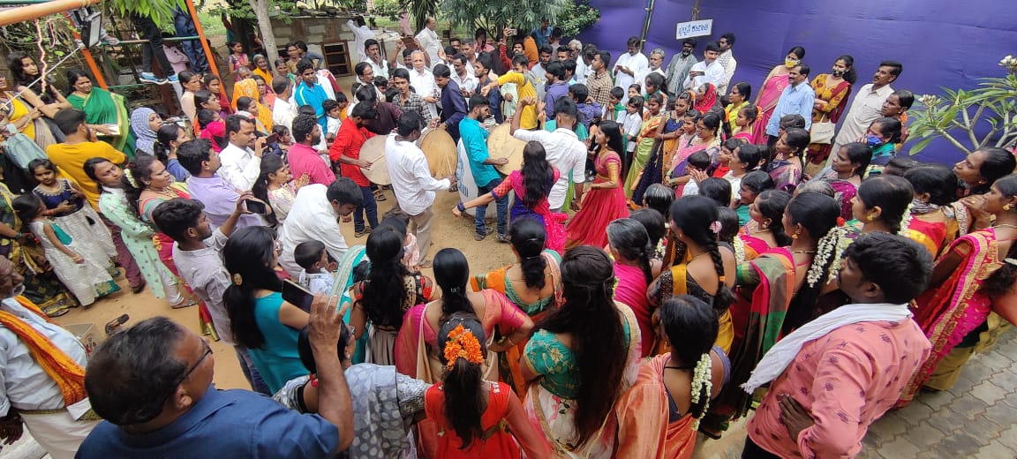
4. Conducting communal harmony meetings/trainings at district for CBOs of Village level and for leader at district level on conflict resolutions emerged by celebrations | 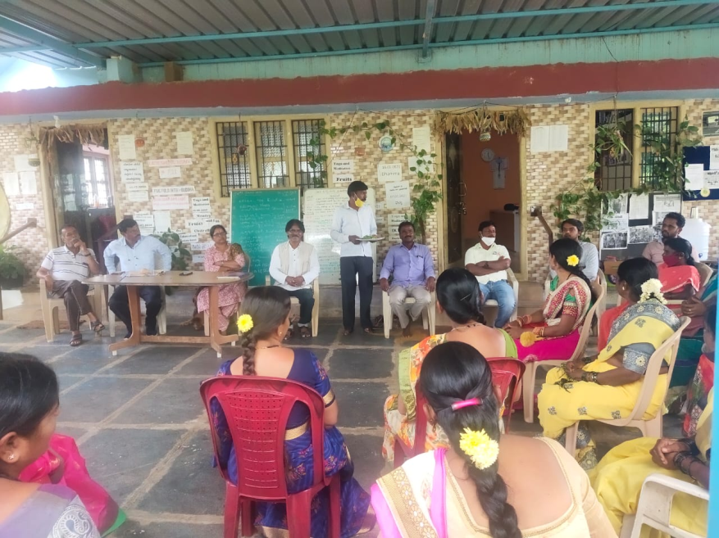  18.8 .2021, one day orientation session was held at Dhamma, for CBOs from different villages on  The orientation was facilitated by Vishwa Sagar and Mr.Seshanna of SPEECH, NGO Chitradurga  On 30.10.2021 at Marapanahalli village level peace committee meeting was held. Attended 22 women and elders attended the meeting. In this meeting GM member Pujiya, Vice president Dhrmappa, Member hanumanthappa, Anganavadi teacher had participated.  13.10.21 at Kyasapura village, 10 village Anganavadi teachers, Women GP members, all together 30 members participated.  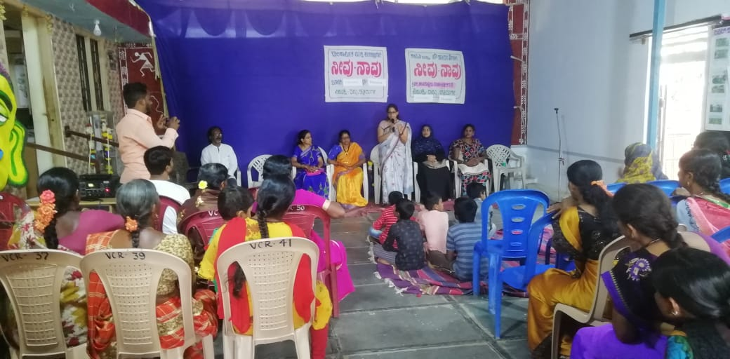  On 17.3.2022, one day communal harmony meeting was conducted at Dhamma on the eve of international women day, focussing on conflict created in the name of Hijab and need for following peace and communal harmony in the community. Dr. Nandinidevi, the CEO of Zilla panchayat, the district social welfare officer, President and PDO of MK Hatti Grama Panchayat, Muslim and Hindhu leaders, and men, women, children from both hindhu and Muslim community had pasrticipated.
5. celebration of solidarity festival (Sadbhavana Habba) in one slum and one village | 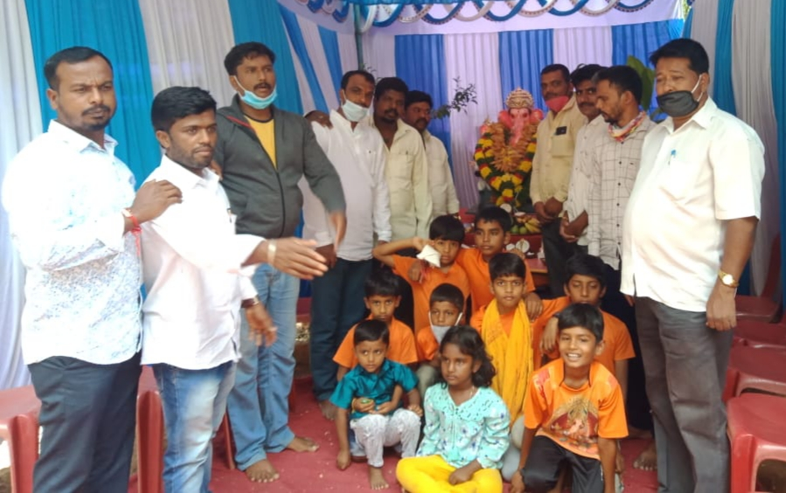  Celebration of solidarity festival by Hindhu, Muslim and Christian families at stadium road, Chitradurga.  01.10.2021 at Kariganur village of Davangere district on 13.10.2021 at Kysapura village, Chitradurga , 01.11.2021 at Dhamma solidarity festival activities were conducted. At all these places 120-150 people from Hindhu, Muslim and Christian communities had participated.  Sharing on the spirit of subaltern festivals and communal harmony-at Sankaranthi celebration, in collaboration with National sports and cultural authority, Neharu Yuva kendra Chitradurga and local NGOs, 15.01.22
6. Additional learning centers for children in Muslim and nomadic areas: cultivating peace and harmony practices in childhood | 5 Additional learning centres are conducted at Neelayanahatti, Filter house, Sadiq nagara, Nayakanahatti and N.Mahadevapura , for Muslim children.  Apart from the regular academic teachings, children are engaged in yoga, meditation, sports, cultural activities and peace education. Children are also given reading –writing materials at regular intervals, Volunteers are oriented on teaching methods and contents and they too are honored with some materials support.  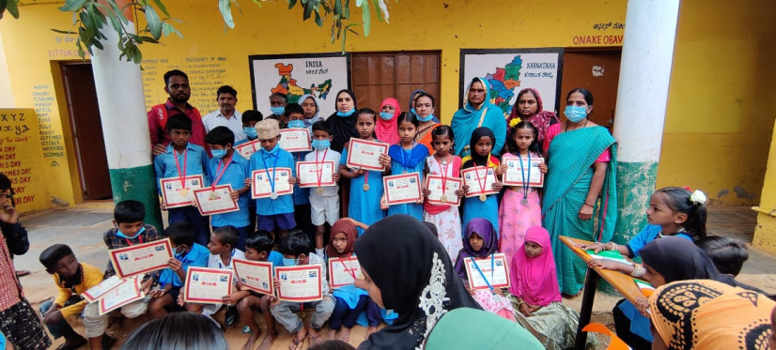
7. Organising Interfaith Dialogue and meeting among various religious leaders | On 14.9.2021 Interfaith dialogue meetings have been held at village and district level for the people from Hindhu, Muslim and Christian communities, including women, men, students and youth . During such meetings, participants are asked to share different conflicts they have faced, kind of intervention been initiated by them to address the conflicts, their real experiences  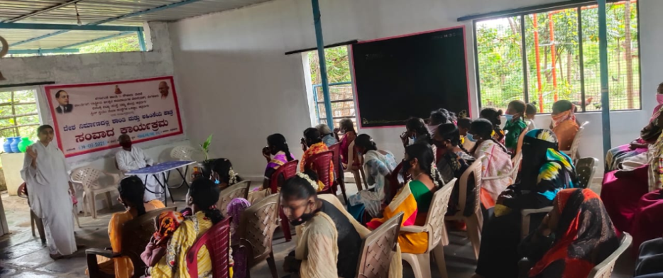  On 1.11.2021 Interfaith meeting was held at Dhamma. It was attended by about 60 participants from different faith.Dr. Nataraj, Fr. Rev.Raju, Sarovar Suryadev facilitated the program.  On 31.12.2021 Inter religious summit was organized at Dhamma. About 60 participants from Hindhu, Muslim, Christian and Buddhist community had participated. The dialogue was facilitated by Fr. Saji George, Mr. Sajjid Arju from Muslim community, Sree Basavanagideva Sharanaru from Hindhu community.  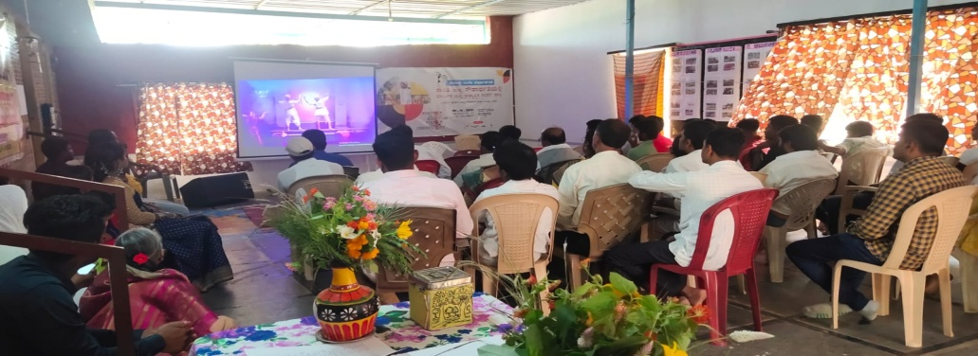
8. Identify and resolve local conflicts in peaceful manner (conducting mediation and dialogue by involving various religious leaders) | 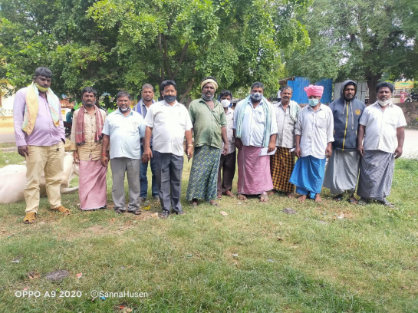For different issues of the communities (Drinking water, road, housing, electricity , caste,  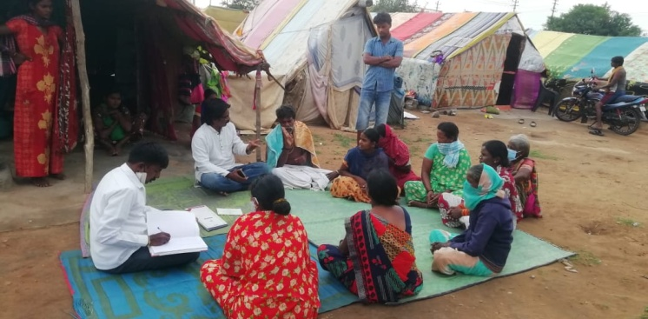  A peace meeting at Challakere village, was held on 24.8.2021 to resolve the conflict and grief situation erupted due to caste practice by higher caste. Mr. Arunkumar, the president of district peace committee sharing the plight of the dalits in the region, in front of officers and community leaders and pressing for resolving the inhuman practice in the area. Finally it was agreed by the higher caste that they will allow the Daliths to public places like temple, tea shops, public water system.  Mr. Kumar and Gururaj the field staff discussing with a group of 2 Nomadic families, at Devarahalli village, over an issue on rift/conflict /rivalry happened on celebration of local festival and case was pending in court. Both the families being poor and living in huts and were victims of circumstances , but had spent lot of hard earned money for legal battle, after series of meeting with the family leaders, the rift has been solved through negotiation and compromises and case was withdrawn.  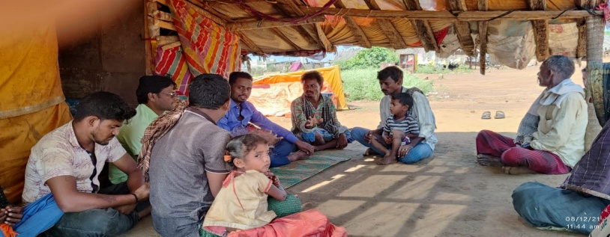
  Type of conflict | Process
  Channakkihonda  Verbal and physical fight between two groups of Nomadic and registering criminal Case in the court | On 7.12.2021 .  As the culprit and victim belong to the same community and poor, the matter was discussed in peace committee, in the presence of Field Organizer Mr. Gururaj. Over 2-3 such meeting, the peace committee influenced both the party to go for peaceful negotiation and as a result, both the party have applied for compromise in the court and waiting for the dismissal of the case.
  Maruthi nagara  Domestic violence | Dadapeer, a muslim person, who was a rag picker use to consume alcohall and pick up quarrel with his wife and use to beat brutally. This was brought to the notice of Beebijan , the Volunteer and a meeting was held with the peace committee members. The PC members like Suban sab, Lokesh, Mahatesh, Ratnamma, Mureugesh had lengtgvy dialogue with the Dadaper and adviced him to live in peace with the rest of the family and the committee took a written agreement from him in this regard.  On 8.10.2021 a peace committee was organized at Veerammanahalli village there was a fight between ST and Lambani community and police case was lodged against both the particies. Mr. Roopa Naik from Vimukthi and Mr. Arun Kumar the president of District peace committee
9. Counselling and advocacy service for victims of various conflicts by intervention of free legal aid service and other counselling service | Submission of a petition to Superintendent of police, along with the parents of victim of rape and murder, demanding for immediate arrest and justice to the victim of the family. As a pressure built by the organization and other forum, the culprit was arrested within 4 days of the incident.  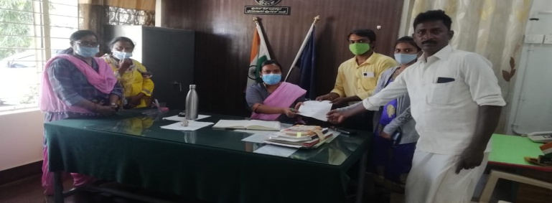  A lady called Supriya, ST caste, aged 26 years(Diverse) had fallen love with an inter-caste minor boy Chandrashekar of Seebara village, belong to SC community(20 years) and they had ran away to an unknown place, for 4 months. This had created tension and conflict between the two families and the mother of the boy had lodged a missing case in the police station. Mother approached us for help in tracing the boy and girl and settled the issue.  Gururaj the MMM project field staff along with the mother, through reliable information traced them, at Kolar and brought them to Vimukthi office. Both the boy and lady had lived together and wanted to marry officially and continue relationship. But, mother and the relatives firmly opposed for the marriage. After verification of the records, it was found that the boy’s age is 20 years and according to law he his minor and if it comes to the notice of police/court, both will end in trouble. We explained the consequences and counseled them to wait till the boy completes the 21 years and if still they wish to marry, they can do so.  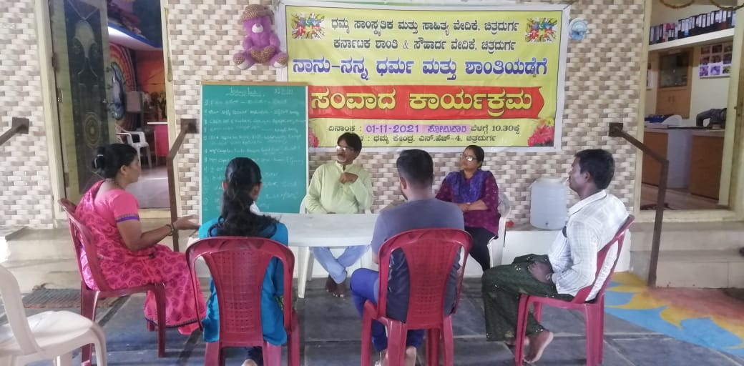
10.Conflict resolution through mobilization of the government schemes and programs for subaltern communities at village/GP level | The Tahashildhar and Panchayat development officer being taken to the spot where land dispute is pending for several years and a meeting was held with the two community (Mundala and Dombidasa) Due to non cooperation, hate and ego the dispute was pending for several years in the high court.  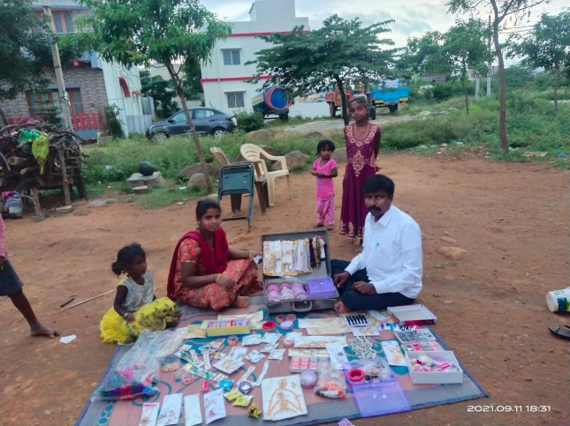  Vimukthi has assisted members of women peace group to avail loan and financial assistance from banks and the government for petty business, animal husbandry  On 30.11.2021 village level meeting was conducted with the Nomadic community on the issues and challenges that they are facing in relation to mobilization of basic amenities. As a follow up on the same day afternoon hours vimukthi took an appointment with the Deputy commissioner and CEO of Zilla panchayat, met the officers along with the leaders from the community and updated on the issues. The officers have assured of taking up development work on the land allotted to Namadic and provide basic amenities requested.  6.12.21 Haliyur and Chitralli village meeting was held for preparing memorandum and to submit it to CEO and DC.  21.12.21 at Nayakanahatti and Devarahalli village meetings were held on the issues of the people, memorandum was prepared and submitted it to GP and Pattan Panchayat.  Sharing communal conflicts and effects on women and children at rotary women wing Chitradurga on 10.12.2022  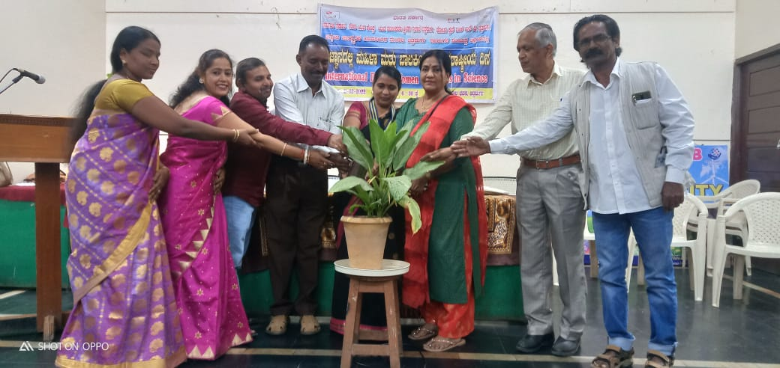
11.Engage inter-faith communities in joint action (common work for development of their slums) | A one day discussion/orientation was held on 4.8.2021 with interfaith communities of Nayakanahatti (nomadic and semi nomadic to share on the problems and challenges faced by them in getting government facilities for the overall development of the village. It was decided by the participants that they will approach the government collectively and commit themselves for common work for the development.  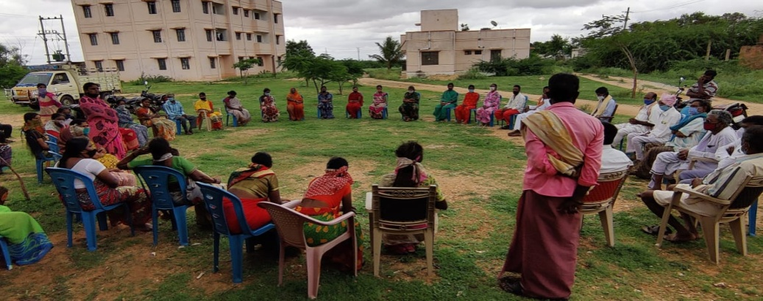  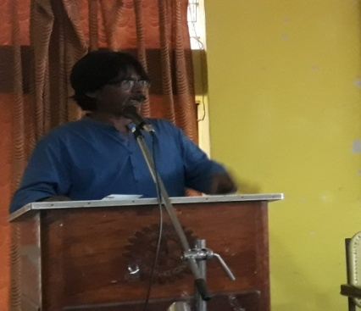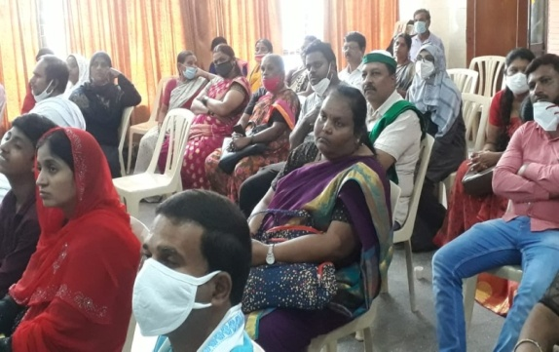  Mr. Vishwa Sagar interacting with a interfaith group , organised by Vimukthi , sharing the kind of threat posed by the communal and dividing forece for the peace and harmony of the communities and the kind of role that we need to play in brining communal harmony, particularly where Hindhu-Muslim-Christian are living together.  On 1.10.21 at Gopalpura government school, a parents and children peace promotion meeting was held . it was facilitated by Beebijan and Aranya. Attended by 5 teachers, 10 parents and 10 students.  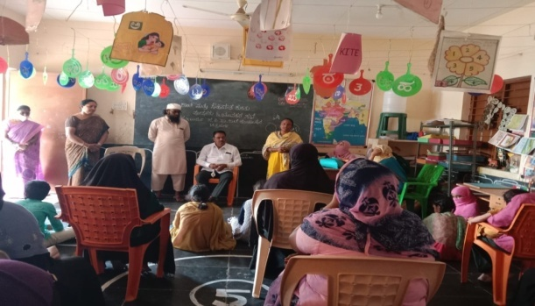  Lobbied with the Rural development authorities and President… the authorities got approval for Rs.40,00,000, for land leveling and related work and prepared themselves for inauguration, inviting the minister Mr. Munirathna.
Staging for Dharana lead by Nomad leaders, Peace committee president Arunkumar, Vimukthi team , demanding for resolving the dispute
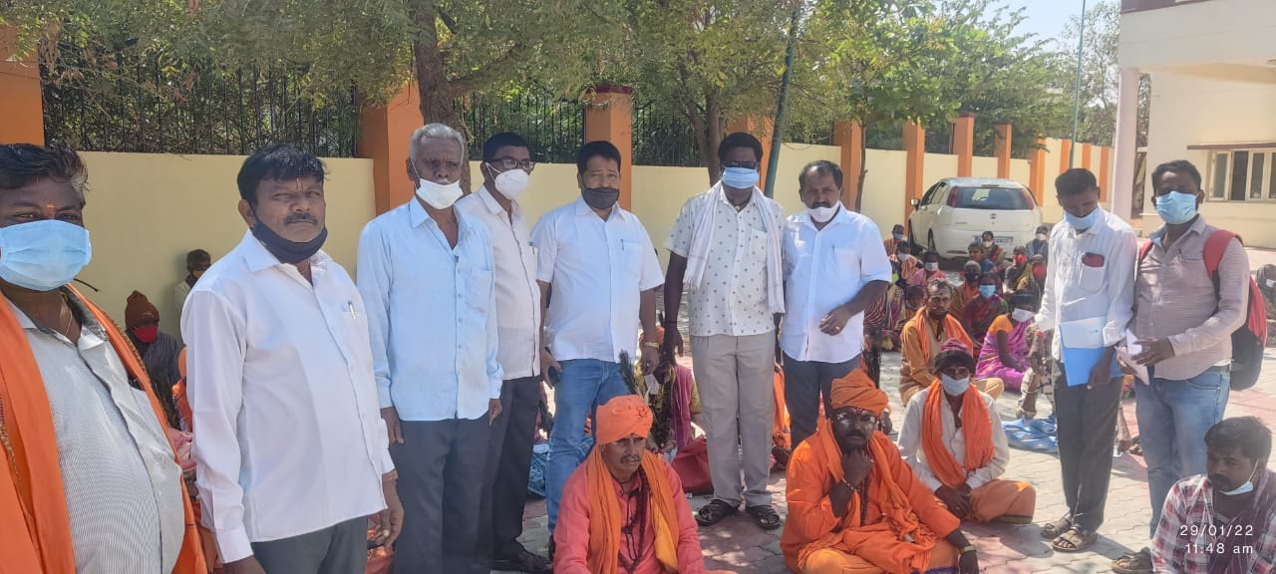

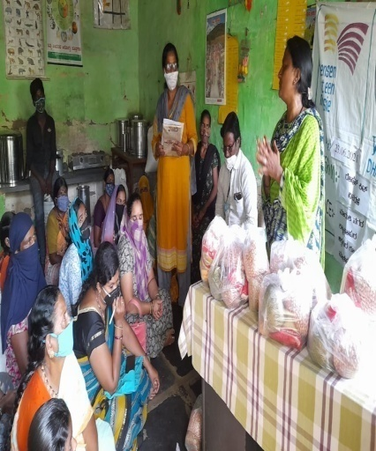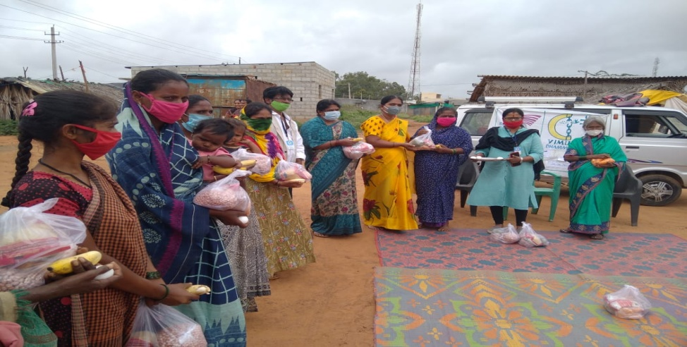
During the Covid-19 , second wave, Vimukthi on the request of Muslim and nomadic area, distributed dry food ration (nutrition) on 12.6.2021 particularly pregnant and postnatal mothers in 2 slums and 5 villages.
Facilitated interview/FGD meeting with Vimukthi team, stakeholders, Hindhu religious leaders for Dr. Richard who had come on a mission to study the power and harmful conviction. We had also orgnised interview with BJP youth wing president, General secretary of All India Democratic Students Youth Forum (AISYF), Interfaith women group.
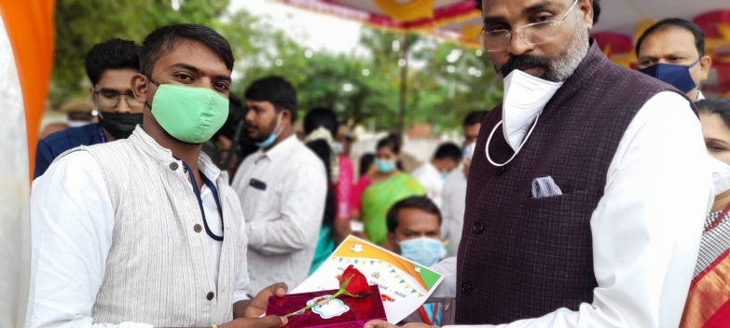
Recognizing the good service rendered by Vimukthi, Chitra DON BOSCO and District Administration , Chitradurga honored Vimukthi on 15th August 2021.
Had Annual general boyd meeting of Vimukthi on 26.6.2021, where the progress report and Expense statement of MMM project was shared and it was appreciated by the General body

- Please describe, to what extent the project has contributed towards achieving the project objectives so far. (Explain level of achievement of output and outcomes as mentioned in the Result Chain in your project)

Outcomes  (copy from your results chain) | Outputs proposed/expected  (Copy from your results chain) | Actual achievement of results  (Please give details)
- Fear, tension and conflicts related to celebration of festivals are resolved in a peaceful manner at panchayats, taluk and district levels | - Interfaith groups are equipped with peace-building and conflict transformation skills | At Vimukthi Target villages, particularly in 5 places, where Dalith, Namadic, Muslims are residing, the fear and tensions have been reduced. However, at City level with a small team of Hindu, Muslim and Christian we have made an attempt to bring different religion come together and celebrate Ganapa festival..
 | - Minor conflicts are prevented from turning violent by the intervention of peace group members | Minor conflicts pertaining to land, house site, caste, religion have been prevented. Particularly in one of the village, in Challakere, were untouchability was practiced (not allowing Dalith to enter in to public places like temple, hotels etc) , the issue was effectively resolved by involving District administration, social welfare department through negotiation and peace process.
 | - Increased participation of members from different religion/faith in festivals expressing solidarity | In the recent solidarity festival conducted at Kariganur village of Davangere district and Dhamma, Chitradurga more than 400 peple, at each place, representing different faith and religion, joined together and celebrated solidarity peace festival.
Interactions among students from different faith are improved and they are engaged in peace promoting activities at home and in colleges | - Students gain knowledge on peace building process, come together to taken up common activities that promote unity and harmony | Due to closer of schools and colleges in Covid-19 second wave, we could not contact students for interaction. However, we were able to mobilise school and college students to Dhamma, from different villages and city and, conducted peace education through audio-video, debate competitions, Where more than 150 students have taken part. Further, at third and fourth week of October, we were able to interact in 7 schools using pamphlets and video.
 | - Joint interfaith activities undertaken in colleges, schools and communities | This has not yet happened.
 | - Children, apart from the academic courses would engage and learn peace promoting sports, art, song, dance and other creative activities | Peace promotion sports, art, song, dance, folk art have taken place in more than 15 villages, 4 slums and at Dhamma centre. These have highly influenced and have made people from different faith to realise the importance of love and respect for all religion to prevent communal violence and tensions in the area.
Peace promoting practices from different faith groups are identified, promoted and practices by children, youth and elders from all faith | - People of different faith come together and participate in a common occasions and express solidarity to one another through cultural shows | One such program at Nayakanhatti, one at Dhamma have been organised. More than 150 people from Hindu, Christian and Islam community have participated and have expressed the solidarity.

- Please narrate the achievement of targets against the indicators.

S.No. | INDICATORS PROPOSED | ANNUAL TARGET | ACTUAL ACHIEVED
1 | Outcome Indicators
1.1 | - 30 minor and 10 major  conflicts are identified and peacefully resolved | 30 minor conflicts  10 major conflicts | 25  8
1.1 | - 300 community members (including religious leaders) actively engaged in conflict resolution. | 300 | 280
1.1 | - 30 active volunteers and 20 religious leaders become peace promoters, influence common people to respect each other’s faith and religion and live in solidarity. | 30 Volunteers  20 Religious leaders | 30  25
1.1 | - 150 persons are benefitted by counselling, advocacy, and mobilization of Government schemes | 150 | 140
1.2 | - 1200 children and 500 college youth have gained knowledge on peace building process  - 150 Muslim children have gained additional academic skills and peace practices | 1200 children  500 college youth  150 Muslim children |  | 1300  350  150
1.3 | - No of peace building practices from different faith groups identified and documented  - 150 people directly influenced by practice of cultural harmony and values of Adivasi  - No of people inspired by local peace practices and following it | 2  150  150 | 1  150  80
2 | Output Indicators
2.1 | - Number of interfaith groups formed  - Number of group members acquired CR skills  - No of minor conflicts prevented from becoming violent  - No of people from other faith participating in religious festivals.  - No of volunteers participated in motivation training and gain knowledge on peace building  - No of religious leaders participated in interfaith dialogues and engaged in conflict resolution  - No of people engaged in joint action for over all development of the community | 10  60  20  200  30  20  150 | 6  58  10  250  65  10  220
2.2 | - No of Youth gain knowledge on peace building process and conflict resolution  - No of empowered students and youth engage in peace building process  - No of joint activities undertaken in colleges and schools  - No of children take part in cultural and sports activities to promote peace | 600  60  30  300 | 150  50  10  350
2.3 | - No of People of different faith come together and participate in a common occasions and express solidarity to one another through cultural shows | 500 | 450

- Please present the income and expenditure for the reporting period in the following table;
Receipt and payment A/c for the period 1st April 2021 to 31st March 2022
Receipt | Amount | Payment | Amount
Opening balance-cash | 143.00 | Motivation and training to volunteers | 28,784.36
opening balance -Bank | 3,231.32 | Peace education in schools and colleges | 50,595.00
Grants received from Mensen met een missie-NL | 1,360,459.71 | Convention of exchange of adivasi, Nomadic | 56,856.00
 |  | conducting communal harmony meetings/ trainings for CBOs | 84,285.08
Bank interest | 4,572.00 | Celebration of solidarity festival | 31,828.00
Advance carried forward of previous year 2019-20 | 23,451.00 | Additional learning centers for children | 10,550.00
 |  | Organizing interfaith dialogue and meeting | 42,200.00
 |  | identify and resolve local conflicts in peaceful manner | 36,472.00
 |  | Counseling and advocacy service for victims | 30,688.00
 |  | Conflict resolution through mobilization of the government | 50,229.00
 |  | Engage inter-faith communities in joint action | 45,981.00
 |  | Field organizers honorarium | 425701.00
 |  | Field organizers travel | 65,794.00
 |  | Field organizers insurance | 6,000.00
 |  | Monthly review meeting | 15,680.00
 |  | Field Director Honorarium | 185,000.00
 |  | Field Director's Travel | 22,000.00
 |  | Accountant cum Office assistant | 72,000.00
 |  | Insurance for staff | 2,000.00
 |  | Printing, Stationary, postage etc | 56,278.50
 |  | Office maintenance | 41,853.40
 |  | Audit, IT filing fees | 22,339.00
 |  | closing balance -cash
 |  | closing balance-bank | 8,742.69
Total | 1,391,857.03 | Total | 1,391,857.03

2021-22 Annual report- Open Hands Project-UK
Vimukthi Vidya Samsthe-Chitradurga
Open Hands India-UK project

Sl No | Proposed activities for  2021-22 | Activities carried out
1 | Rescue and rehabilitations of children with disabilities:  - Medical camp and referral service for poor and needy children with disabilities at Village/slum and Dhamma level.  (50 specially challenged children from Target area slums and villages) | On 3.6.2021 a Covid-10 Carona virus awareness was conducted at Sulepete in a Anganawadi for mothers and young girls (15 members) . Similar orientation was conducted on 7.6.21 at Jattur village (20 members) In both the village Asha health worker, Anganavadi teacher and Surekha oriented the participants  6 young girls who are malnourished and belong to poor families were given fruits and eggs mobilized from local donors.  On 09/06/2021 a Zoom meeting was Held, to share and discuss on the following Agendas:  - Progress and problems in conducting SHG meetings and Savings due to lockdown  - Impact analysis of situation due to Corona virus and lockdown, among SHGs and in the area.  - Support: medical, ration kit and other served by the Government, private institution and individual donors.  - It was facilitated by Mrs. Annapurna and supported by Vimukthi staff and volunteers of Chitradurga and Chincholi block  - Participants like Mrs. Kumaramma, amrutha from uchangi yallammadevi SHG, kavitha and Lakshmidevi from Kanivemaramma SHg, Gowthami and sumithra from Chamundeshwari SHG, Venkatamma and ramakka from nayakanahatti Maheshwari SHG, Nagarthamma and Lakshmi devi karibasveshwara, Gangamma and Savithramma from Chowdeshwari, Kamalamma, Jyothi from Devarahalli Thuppadamma SHG, Susheelamma, nagarthna from MK.Hatti Sahasi, Narasamma, Vijayamma from vijyanagara BHuvaneshwari SHG, Pavana and Pallavi from maruthinagara Mahalakshmi SHG, Nagamma and gangamma from Medhehalli Gangadevi SHG were actively participated.  - All the participants shared that due to lockdown and fear factor women are not coming for the meeting and saving is not taking place. However, in two places (Maruthinagara and Nayakanahatti) meetings and saving is continuing as they do not have issues with Covid-19 2nd wave  - All the participants shared that due to lockdown they have lost their daily labor/work/business and it has become hard time for their sustenance. On the other hand , no government and private agencies have comeforward to their rescue.  - A memorandum was prepared on the basis of the zoom meeting by Vimukthi demanding for the ration kit and medical assistance . As a result local government took step to provide ration kit at Nayakanahatti, Medehalli, Haliyur.  Further, based on the demand expressed in the zoom meeting by the project women, Vimukthi took initiative of distributing ration kit (protein dry ration) to Post Natal and Pregnant mothers in selected villages/slums and distributed the same On 23/06/2021 , under existing grant of OHI for 61 mothers as following:  - Chikkapura Gollarahatti (11)-Backward section women  - Ashraya Badavane/ colony (07) Dalith and muslim ladies  - Maruthinagara (30)-Muslim and Hindhu  - Kyasapura (13)-Dalith women  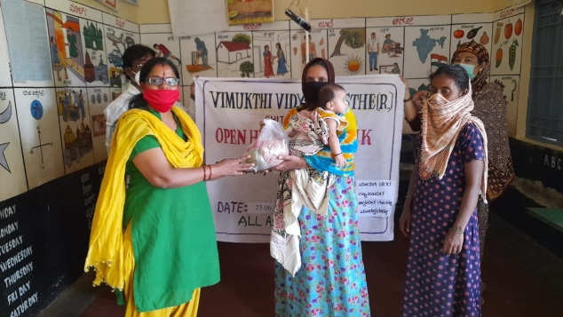  On 21.6.2021, on the eve of International yoga day, a yoga session was held at Gowtama Budha school, Sulepete by Surekha and in 5 places in Chitradurga , focusing the physical and mental wellbeing of the participants, particularly in Covid-19 pandemic period.  On 14.7.2021, four multiple disabled children from MK Hatti and Malappanahatti village, along with parents were taken to government Hospital for medical checkup and treatment. Dr. Rahiman Khan of District AYUSH department diagnosed the children and proived the medicines. Children were facilitated by Gururaj and Kumar H.  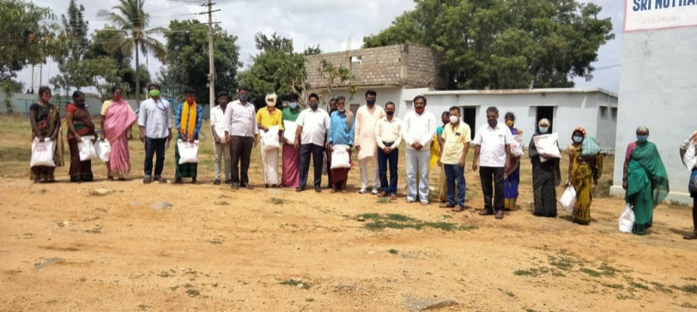  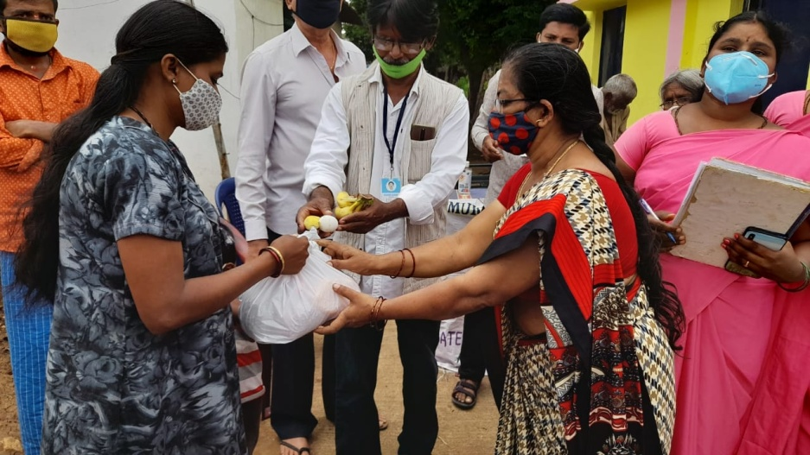  On 22.5.21 one day training was conducted for young girls and boys on personal hygiene at Sulepete, by Health educator, Asha health workers from Primary Health centre, Sulepete, facilitated by Surekha.  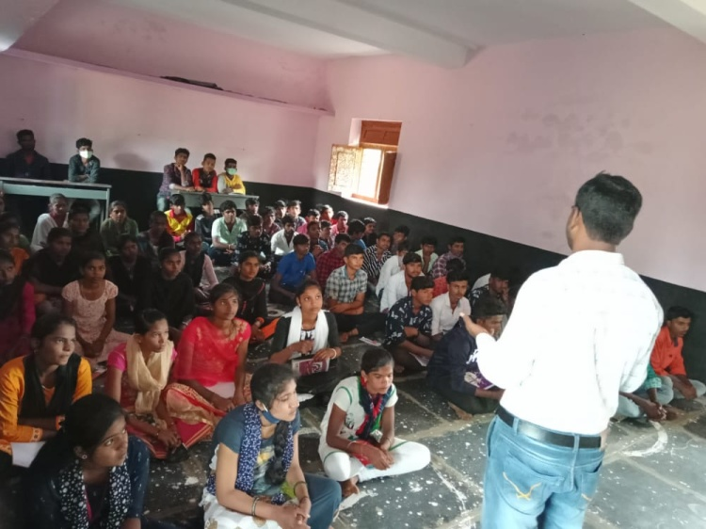  Similar orientation was conducted on 26.7.21 one day training was conducted at Nidaugunda, Chincholi, By Renuka  On 17.8.2021 Eye check up camp was conducted at Nidugunda Village, Dr. Sruthi the eye specialist, patents and general public had participated. Bichhamma a specially challenged women was given spectacles from the hospital.  Pregnant and postnatal mothers were given egg, fruits at Chincholi block, mobilized by Surekha.  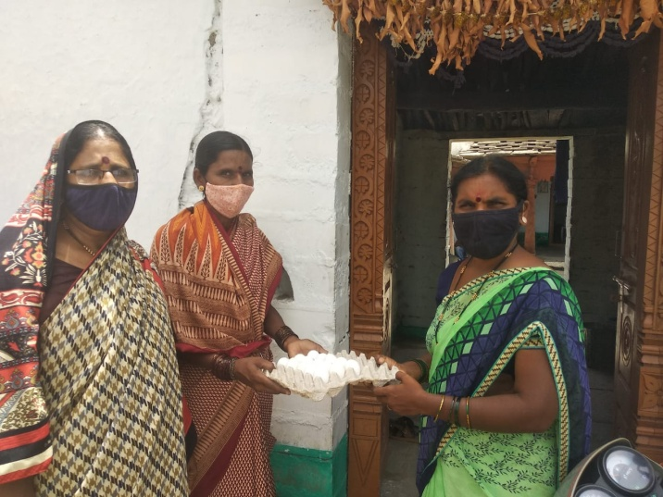
1 | - Enrolling in to mainstream/special schools of children with disabilities and medical referral service  (30 specially challenged children will be aimed to enrolled for formal education) | 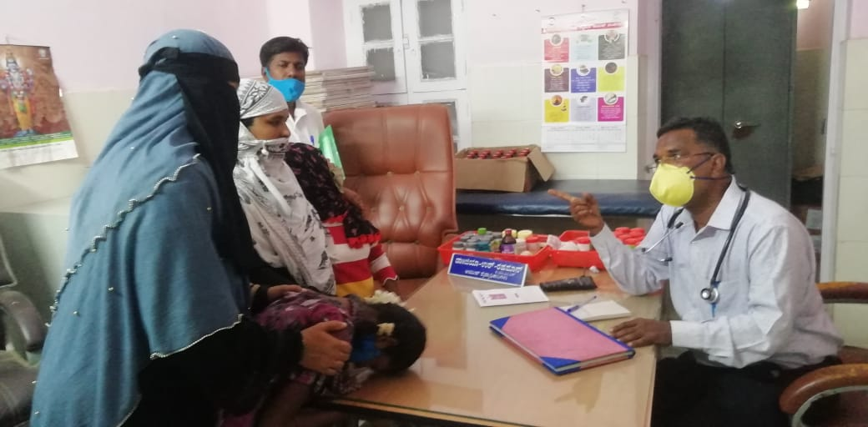
2 | Health, education and skill empowerment of youth (teen age girls)  - Health camp on personal hygiene for teen age girls  (150 teen age girls suffering from various health hazards) | A zoom meeting was held with selected young girls (Kishori)- on 12/05/20201 on situation of corona virus in their area, safety measures to be taken as preventive measure, and personal hygiene related. It was facilitated by Annapurna with a resource person called Mrs. Asha, from Bangalore Colombia Hospital. The resource person interacted effectively with the girls, made young girls to share on the issues related and educated the participants on how to care on personal hygiene. There were 4 young girls from MK. Hatti, 7 girls from Nayakanahatti, 2 girls from Devarahalli, 2 girls from Goolayanahatti, and 2 girls from Vijayanagara.  The second zoom training was held on 11/06/2021 morning 11 for young girls from next batch of villages: .  The training was facilitated by Mrs. Annapurna and Resource person from District Health office, Chitradurga, Mrs. Janaki, the health educator.  She explained the importance of wearing face mask, frequent hand wash using sanitizer, maintaining social distance. Further she replied for the questions raised by the participants pertaining to personal hygiene . Girls of 10-22 years old had taken part in the orientation. 3 girls from MK hatti, 9 girls from Chennakki Honda, 2 girls from Thalaku, 3 girls from devarahalli, 1 from Shapura, 2 girls from Sulepate, Chincholi block, totally 26 actively took part and benefited out of it.  On 7.8.2021 at Chimmaidaliya village parents and young girls were oriented on personal hygiene.  On 18.8.2021 orientation was conducted at Sulepete office for girls through Asha health worker, Anganavadi worker and Surekha for 4 young girls.
2 | - Career guidance to continue higher education to acquire adequate knowledge on right education and right livelihood life  (100 girls who are pass/fail in 10th, 12th, Diploma and degree courses) | One Day training on  Career Guidance and skill Development  For Ladies (16 to 22 years old)  Date: 14.07.2021 10.AM  Place: Dhamma Campus, Near Kapra Petrol Bunk, MK Hatti, Chitradurga  Activity Chart  Introduction and creative games Mr. Aranya Sagar.V  Vimukthi, Chitradurga  Skill Training in Chitra Donbosco Mr. Pradeepkumar. N.K  Training Coordinator, Don Bosco, CTA  Skill training in RUDSET Mrs. Manjula.G  Director, RUDSET, Chitradurga  Orientation on Career Guidance Shri. Gagendra Naik  and opportunities State Resource Person and expert in Career guidance  Kitchen gardening and livelihood Mrs. Annapurna  President, Vimukthi Vidya Samsthe,  Follow-up Programs in Dhamma Mr. Vishwa Sagar.R  Director, Vimukthi Vidya Samsthe,  Program facilitation Mr. Gururaj.A, Coordinator, Vimukthi,CTA  About 40 young Girls, from 6 villages and 4 slums had participated.
2 | - Skill up-gradation orientations on traditional livelihood and modern livelihood programs  (20 selected girls who have some basic skills in traditional occupation and modern skills ) | On 18.9.2021 , one day skill up gradation training was held for 32 young girls from 8 villages and 4 slums, at Dhamma. Following resource persons conducted the training using training materials (Computer, sewing machines, old cloths, scissors, crossers, lemon and other ingridiance.  After the training and exposure to Dhamma land, a meeting was held with the participants to decide on the course that girls would be interested for learning.
  Name of skill | Participants | Resource person | Number of girls preferred to attend on every Sunday at Dhamma, for three months
  Computer basic skills | 32 young girls, studying, dropout in 10th, 11th ,12th and Degree | Aranya Sagar.V | 22 Girls | 10 AM to 12 PM
  Tailoring and embroidery |  | Sarashwathi | 22 Girls | 12 .15 to 1.30 PM
  Spoken English/ Grammar and Yoga |  | Vishwa Sagar | 22 Girls | 2 .15 to 3 .30 PM
  1. Organic Agriculture , compost manure and horticulture.  2.Country chicken and rabbit rearing  3.Pickle making and Mat weaving |  | Aannapoorna | 10 | Every Saturday  2 PM to 4 PM
  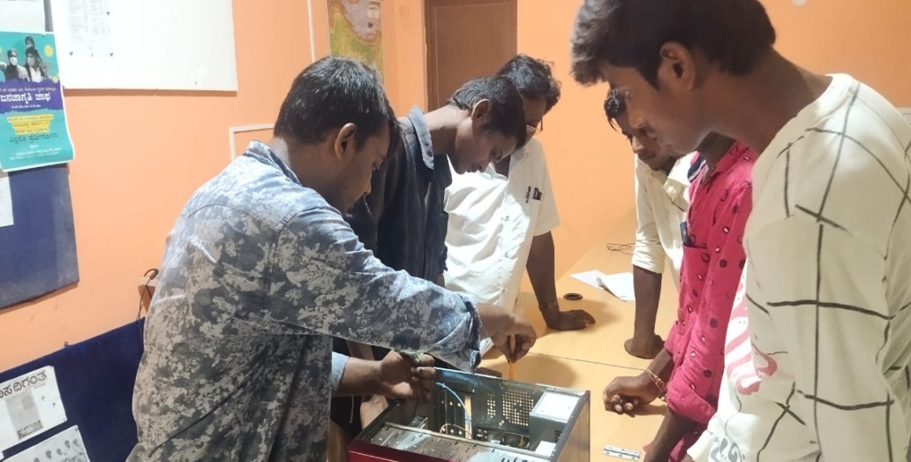
  Computer class by Aranya and Arpitha
  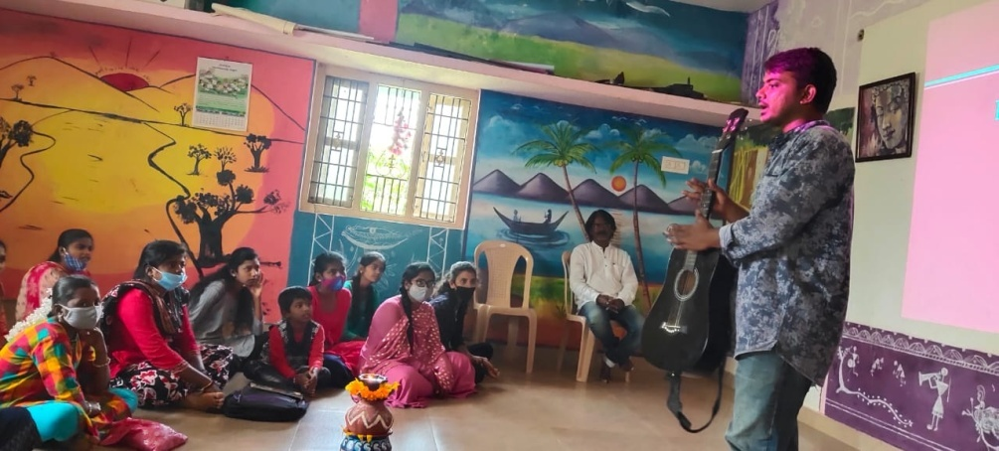
  Instrument music class by Aranya Sagar
  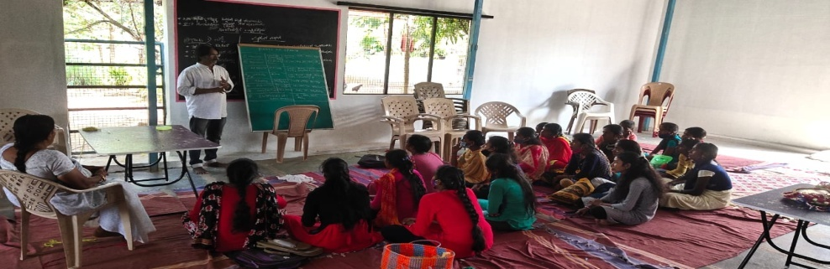
  English Grammar and Spoken English by Vishwa Sagar.
  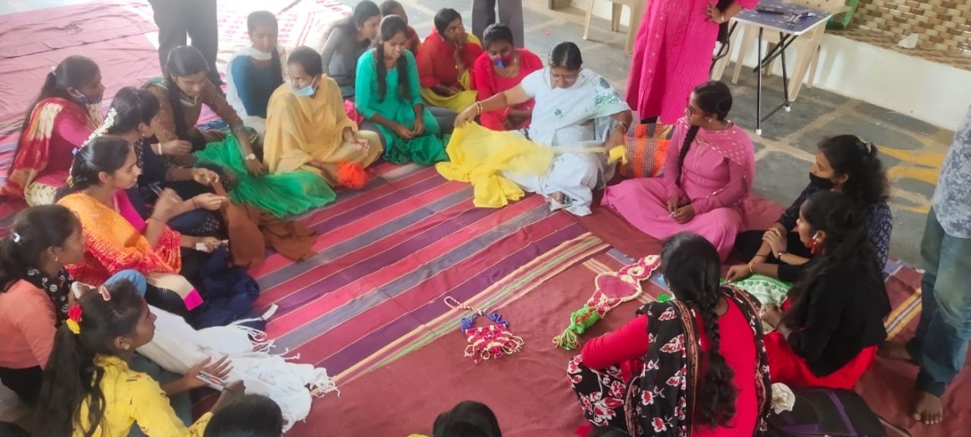
  Hand embroidery, wire bag making by Sarashwathi madam
  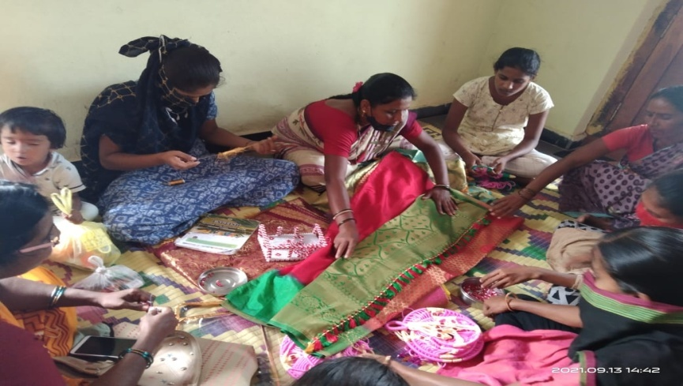
  Hand embroidery and tailoring training being imparted to young girls at Nidugunda by Renuka (above) and A volunteer at Chinmulaida , facilitated by Surekha (below)
  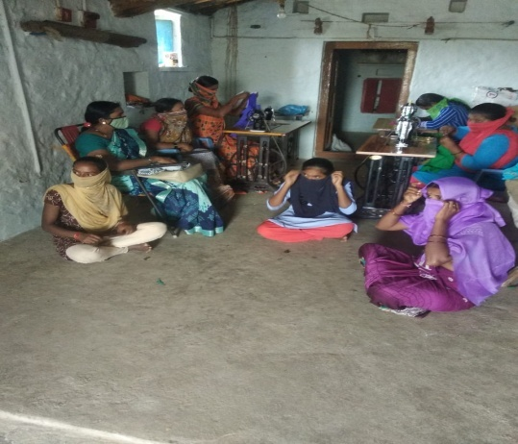
3 | Empowerment and Livelihood programs for women:  - Skill up-gradation / training of active members of SHGs in Agriculture, animal husbandry, kitchen gardening, home products etc.  (100 poor and marginalized, members of SHGs, identified by SHG federation, aspiring for skill training and wanting to become self employed and improve family income will be assessed, selected ,trained, follow up support is given in terms of startup the business) | 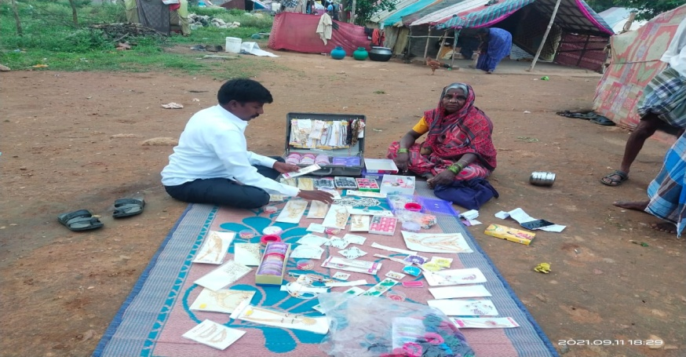  A women beneficiary showing stationary items bought for business and another beneficiary bought young sheeps to rear, with the help of Bank loan, mobilized by Kumar H, for SHG members(12) Rs.2,00,000.  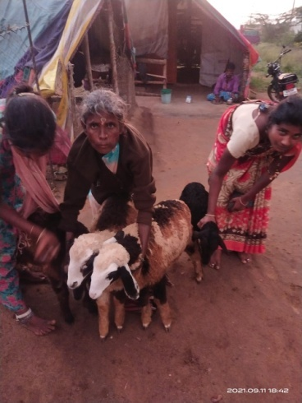  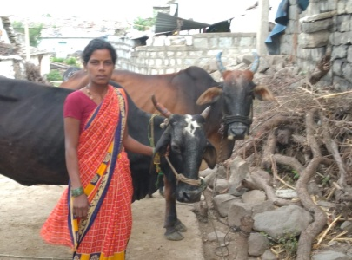  A women beneficiary bought cows with the bank loan , at Nidugunda village, Chincholi  On 29.7.21 one day training was conducted at Pasthapur village for members of SHGs on Animal husbandry, kitchen gardening was conducted.  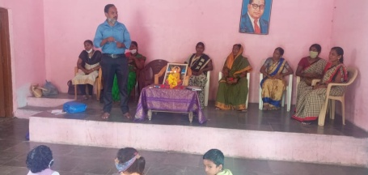  On 3.8.21 visited Child development Project office and had discussion on the livelihood activities of the government (above picture) and participants (below picture)  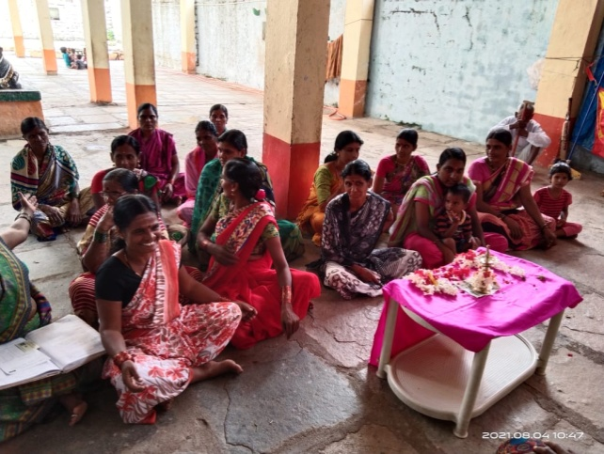  Surekha has assisted 6 unemployed artists to apply online with the Kannada and Culture department, for artist fellowship and monthly pensions.  On 15.6.2021 widow pension for one person and 4 persons for old age pension applications have been applied by Surekha.
3 | - Linking with MNREGP for employment, development of rural assets, improve the socio-economic condition.  (About 500 rural women will be linked with MNREG work) | On 24.7.21 one day orientatgion was conducted at Venkatapura Tanda on social and economic development, MNREG related.  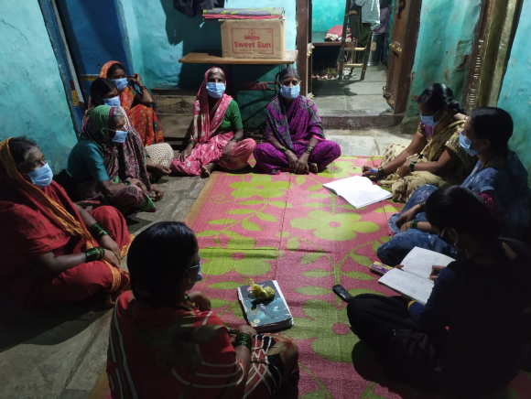  SHG members discussing on MNREG related subject at Pastpur village, Chincholi  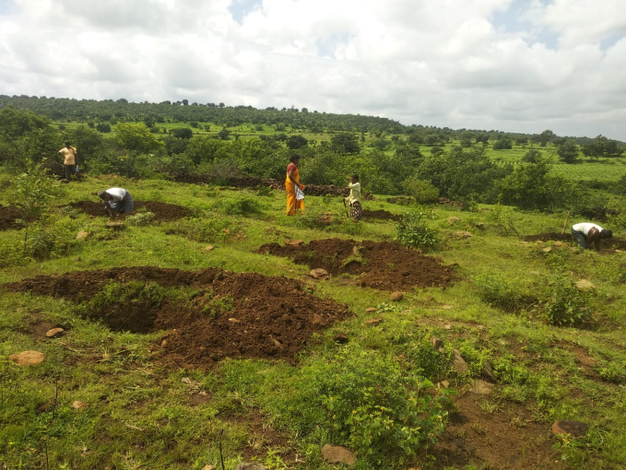  Men and women engaged in MNREG work in Chincholi area, assisted by Surekha
3 | - Empowerment of newly elected Grama Panchayat women members on the Panchayt Raj Act, powers and schemes  (About 100 women from 20 GPS will be trained) | On 30/06/2021 one day training was conducted for newly elected female members of Lakshmi sagar GP and Iyanahalli Gram panchayat (local self governance body)  - Role women in preventing child marriage and child labor in their village  - Active participation at Grama Panchayat for overall development of women and children  - Promoting agendas relating to organic farming, horticulture and animal husbandry at GP meeting  - scheme and projects for women and children In GP  Mrs. Gayathri, the Project and planning officer of Zilla Panchyat, Chitradurga shared on schemes and programs of GPs and women leadership. Mr. Manjunath, the senior trainer from Don Bosco oriented on issues pertaining to women and children. Vishwa Sagar.R interacted with members on experiences of women on organic and sustaible agriculture and exposed participants to Dhamma experiment land .  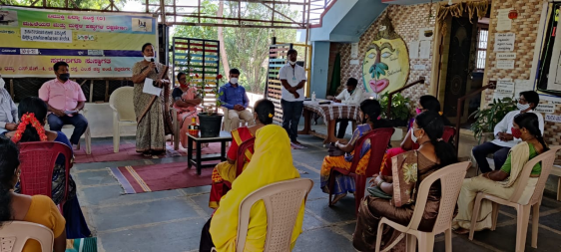  Similar training was conducted on 24.8.2021 for another three Grama Panchayat women, at Dhamma , attended by 21 members from MK hatti, Medehalli and GR Halli GPs. The orientation input was given by the Executive officer, Taluk Panchayat, Chitradurga, Mr. Shankrappa VK of Child and women help line, Vishwa Sagar.R  Photos of Medehalli, MK Hatti and GR Halli GP training as below:  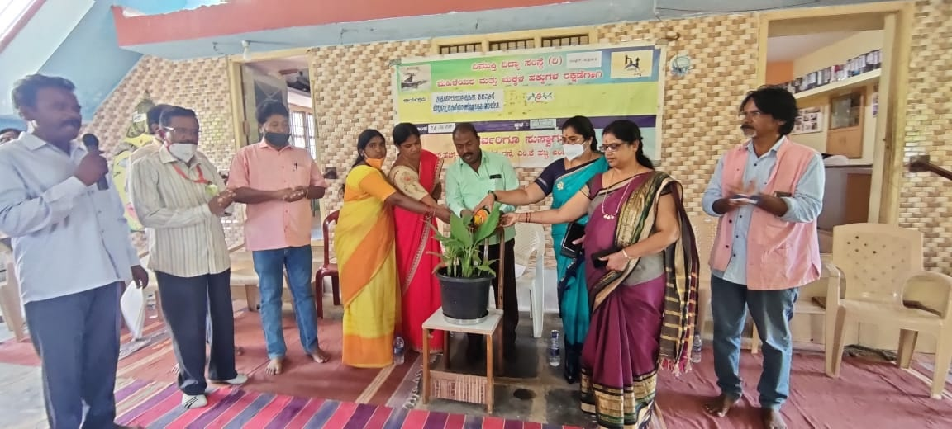  Taluk Panchyat EO, women and Child line officer, GP lady presidents inaugurating 2nd batch training at Dhamma (above) and participants (below)  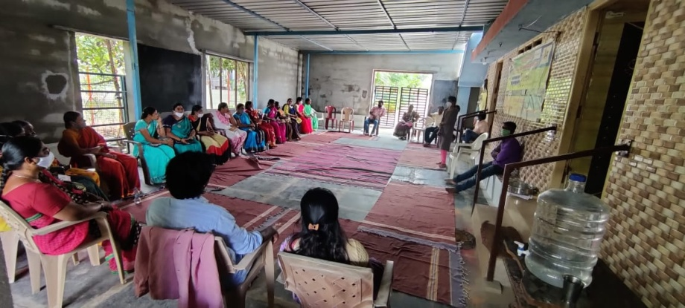  Surekha and Renuka, discussing with Lady President of Grama panchayat to take up training for newly elected members in Chincholi block (below photo)  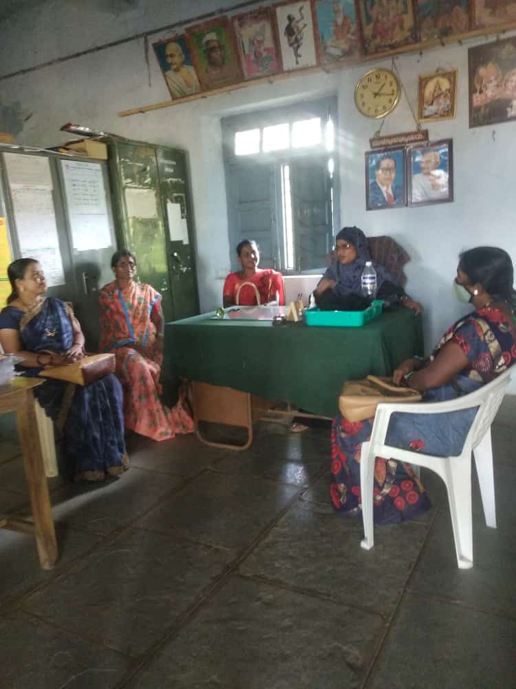
4 | Protection and preservation of eco system:  - Awareness on issues and responsibilities pertaining to Eco-system for youth in schools and colleges.  (10 high schools and 5 colleges in the area, About 500-1000 students, teachers will be covered) | Due to Covid-19 second wave and lockdown declared and schools and colleges are not functioning. Hence, we could not undertake awareness programs at school and college level. However, we were able to mobilize college students to Dhamma and organize awareness on eco system, particularly role of youth/students in protecting and preserving the eco system. We also took them for Dhamma campus walk, where plants, animals, birds, human being are living together and organaic/sustainable agriculture is practiced.  Above training was conducted on 2.8.2021  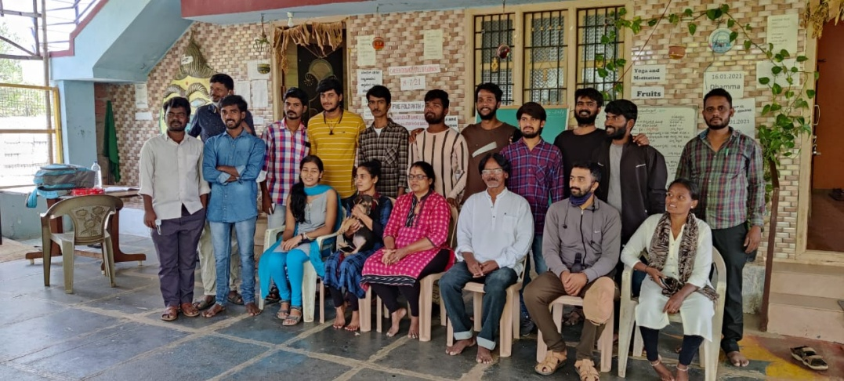  College students from different part of Karnataka, being oriented on organic farming and eco sanctuary at Dhamma  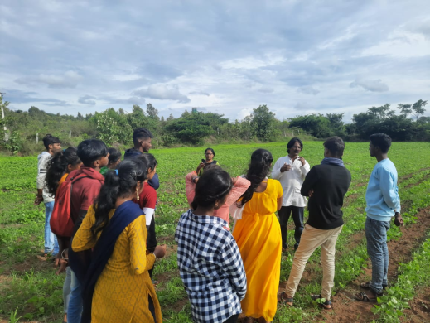  On 5.9.2021 College students from Tumkur University (BSW) being oriented on organic farming and eco sanctuary at Dhamma  On 23.7.21 an orientatgion session was held at Alkoda Government school on protection of environment and growing trees in school yard and on road sides.  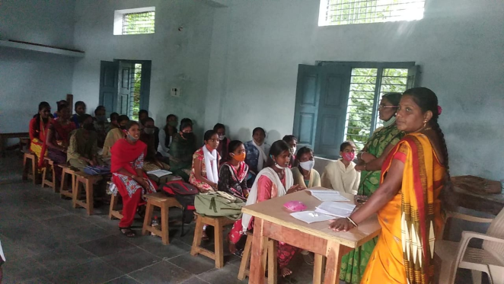  On 24.8.21 at Huvinahalli village an orientation session was conducted for school children and teachers on preservation of environment and got engaged in plantion of saplings in school compound .  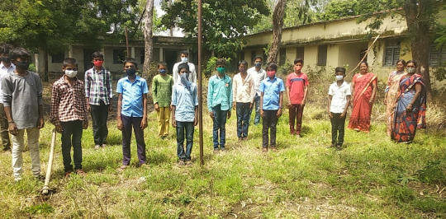  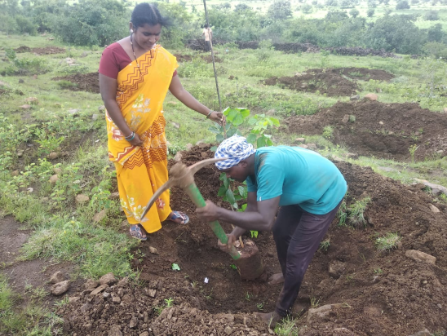  On 24.9.2021 at Nidugunda government school an orientation session was conducted for children and teachers .
4 | - Strengthening the informal organic farmer’s forum for sustainable organic farming.  (Experience of 20 organic farmers will be documented, shared and other farmers will be motivated to go for organic farming) | On 6.8.2021 , In collaboration with agriculture department, SPEECH NGO we had organized one day orientation cum exposure for women farmers of Chitradurga taluk, at Dhamma, where 32 women had participated. They were oriented on importance of organic farming and sustainable agriculture.  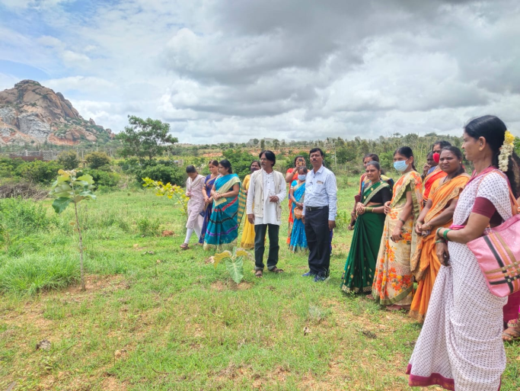  Women farmers being on farm orientation at Dhamma  On 10.7.2021, an orientation on sustainable agriculture was conducted at Jattur village , Chincholi block farmers.  On 6.8.2021 agricultural seeds were distributed through agriculture department for Lakshmi SHG of Gandhinagara. (uddu, hesaru, togari) cereals
4 | - Eco –friendly activities in Dhamma land (cultivating millets, promoting eco sanctuary, child friendly, environment,dhamma organic outlet.  (5 acres of land will become model for training, motivation and) | In five acres of Dhamma land, 50 country chicken, 9 rabbits, 5 cats, 3 adult dogs, 2 wild mongooses, 3 wild bears, 3 peacock, several snakes, birds, rats, lizards and other number of creatures are regular visitors to Dhamma and some have taken shelters and are living in harmony.  Several hundred, different fruit, timber, medicinal, flower, show plants are taken care and growing healthy and greenly.  In July-august-September , cultivation of land, cleaning, sowing of millets , cereal, vegetables, ground nut, weeding work is carried out following organic agriculture practices and crops is growing in green.  A vermicompost pit is created with the support of Grama Panchayat.  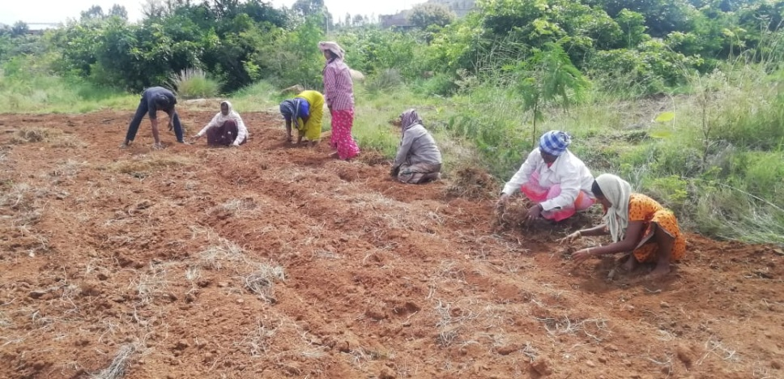  Clearing grass in Dhamma field by local women  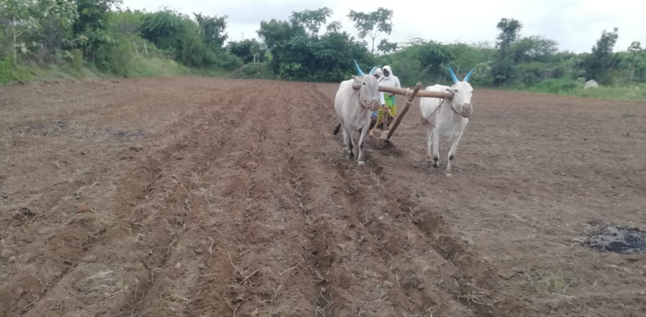  Sowing millets on 14.8.2021, with the help of local farmers.  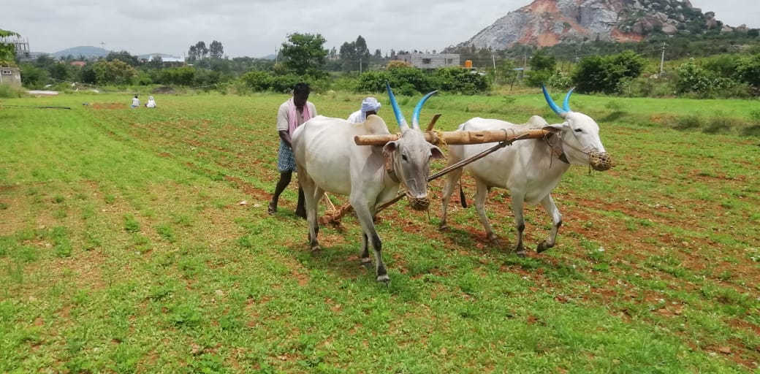  Clearing waste grass in Ground net field  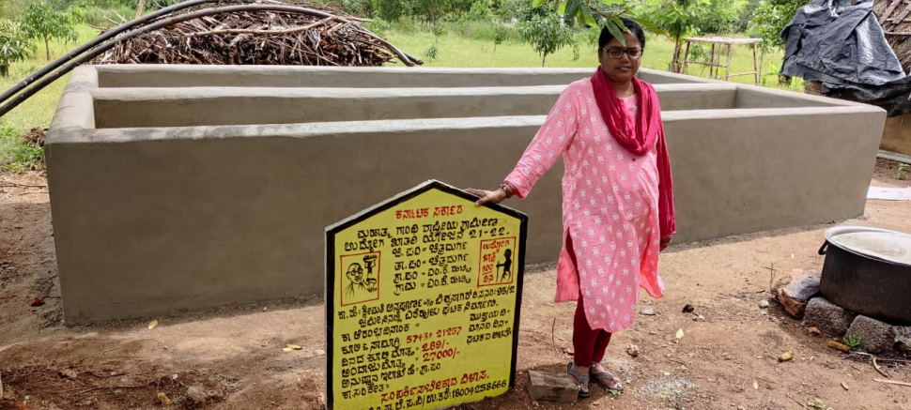  Vermicompost pit being built in Dhamma with the support of GP and OHI

Vimukthi Vidya Samsthe-Chitradurga

Quarterly report for the period October to December 2021

Sl No | Proposed activities for  2021-22 | Target group
1 | Rescue and rehabilitations of children with disabilities:  - Medical camp and referral service for poor and needy children with disabilities at Village/slum and Dhamma level. | Below-24.12.2021 Medical checkup camp was organized at Dhamma. Dr. Shivakumar, Ayush Department, Akshay Karandi the Physiotherapist, and guest Arunkumar, Shankrappa of Child line and Vimukthi team had participated. 20 Specially challenged and 20 parents/care taker had participated.  Medical checkup was carried out and Ayurveda medicine was given by Dr. Shivakumar and parents were counseled to follow process. Physiotherapy of Multiple disabled and physically challenged children was carried out by Akshy Karandi.  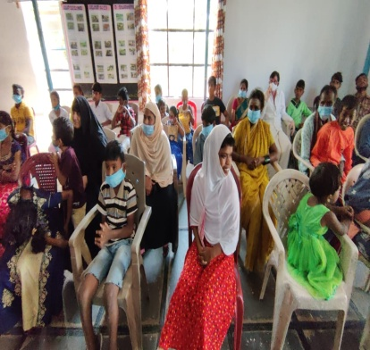  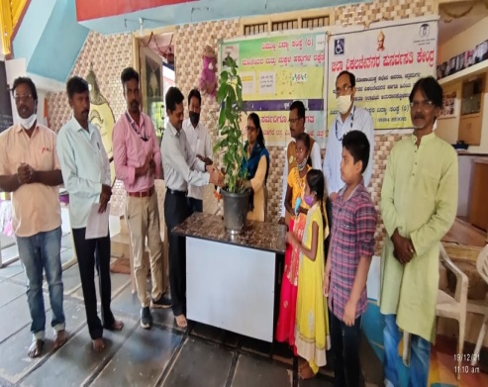  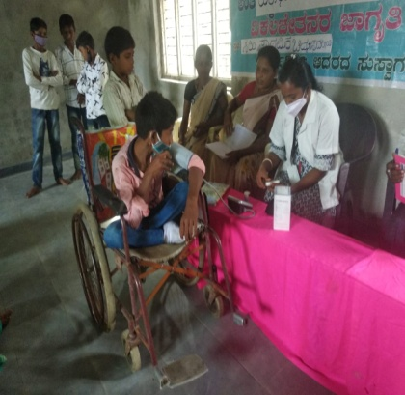  Above and below- Medical checkup camp was conducted at Chincholi block by Surekha and Renuka for disabled, old aged persons. About 45 parents got benefit by the camp. Doctors and Nurse form a government hospital, nearby attended and after diagonalization, provided medicine.  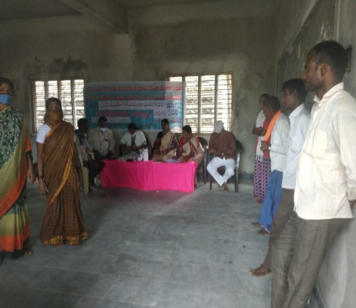  On 30.11.21 UDID card (Disabled card to seek government services) for a child was obtained and for another child jaheba the application for UDID has been submitted online.  Further on 15.12.21 Dental medical check-up camp was held at Chincholi taluk hospital. People from three target area of Vimukthi were mobilized for the checkup and treatment.  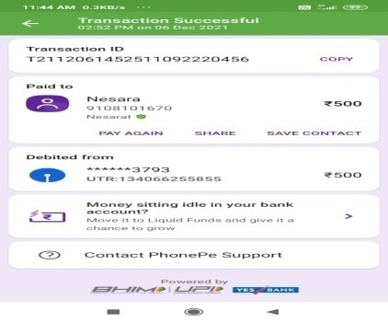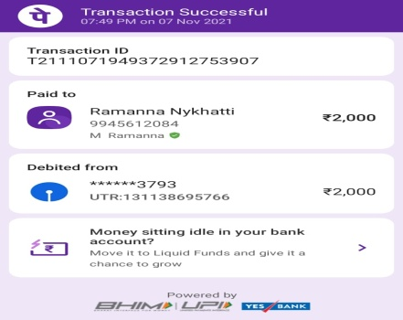  Above- Nesara, a girl who is suffering from Thalassemia disease (white blood cell deficiency) has been regularly assisted by Vimukthi for blood transmission , every month and Mr. Ramanna, a nomadic tribe who is suffering from heart related diseases has been assisted with Rs.2000 for referral service at Bangalore.  On 7.12.2021 a disabled child called Sonia was enrolled in to specially challenged school (visually challenged).
1 | - Enrolling in to mainstream/special schools of children with disabilities and medical referral service | On 25.10.2021 a Visually challenged girl Shaila D/o Siddalingappa from N Devarahalli village, 10 years old has been successfully enrolled in to a visually challenged special school at Davangere.  A multiple disabled girl called Suma has been enrolled in to specially school at a private school, Bangalore.
2 | Health, education and skill empowerment of youth (teen age girls):  - Health camp on personal hygiene for teen age girls | Below- On 10.11.2021 personal hygine orientation was conducted at Sulepete by Sureka and Health worker.  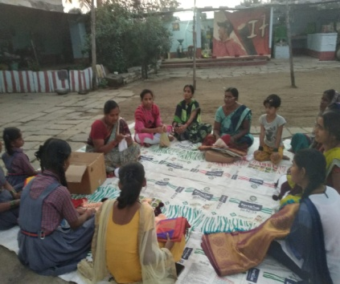  Below , Arpith Vimukthi volunteer organized personal hygiene camp for teen age girls on 06.12.2021 at GR Halli village.  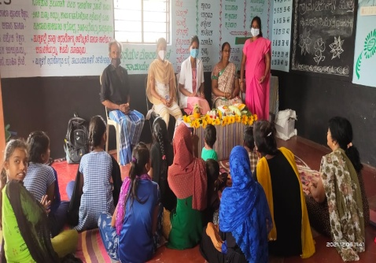  Below , On 19.12.2021 an orientation on personal hygiene was conducted by Annapurna at Dhamma. It was attended by 15 teen age girls from 3 slums, Chitradurga.  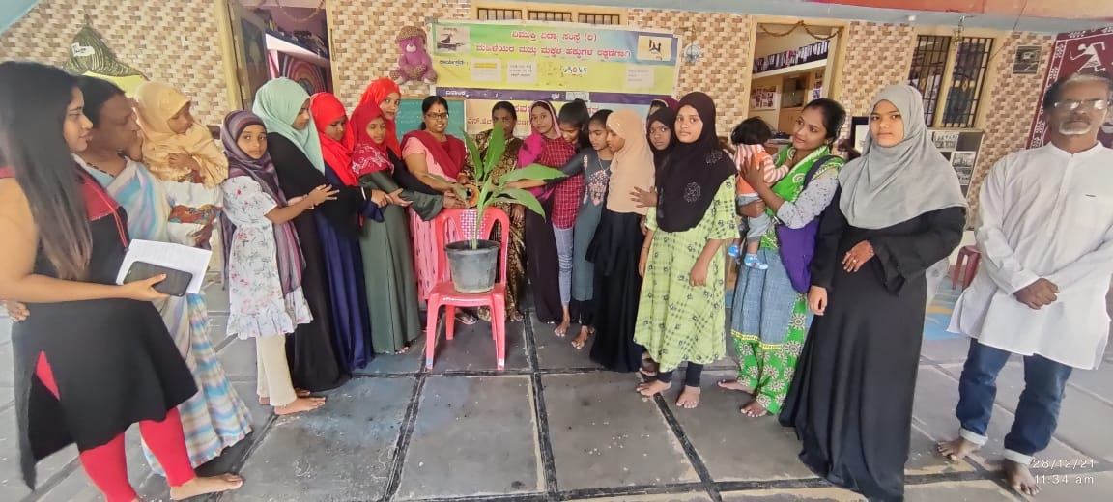  On 10.12.2021 a personal hygiene orientation session was held for Kanya School, Sulepete. The session was conducted by Taluk Health educator Mrs. Gurubasamma, kavitha . it was attended by 30 young girls, HM and Vimukthi staff.
2 | - Career guidance to continue higher education to acquire adequate knowledge on right education and right livelihood life | On 19.12.2021 an orientation on Career guidance was conducted by Vishwa Sagar, at Dhamma, attened by 15 girls, 5 mothers from 3 slums.  Similar orientations have been held at Nayakanhatati and Chincholi block by Maripalaiah, Surekha and Renuka  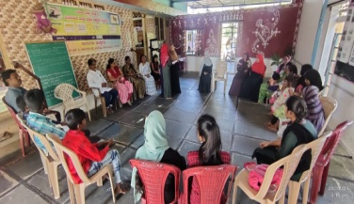  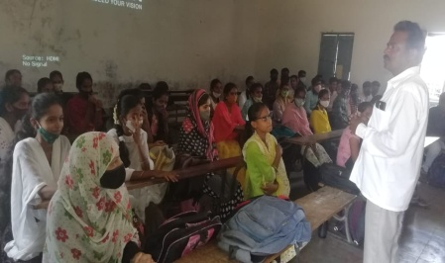  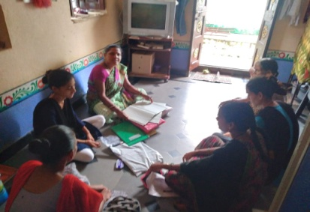  Below-On 13.12.2021 career guidance orientation was held at Kupanur village. Taluk officer Tabassum madam and vimukthi team took session for girls  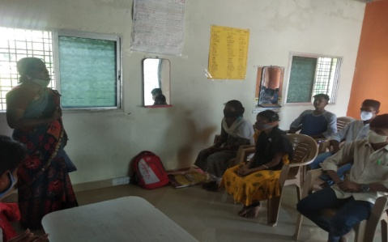
2 | - Skill up-gradation orientations on traditional livelihood and modern livelihood programs | 6 months tailaoring training has been initiated at Dhamma for girls. Currently 3 girls are undergoing cutting and stitching training, both theory and practical classes, conducted by Annapurna  Similarly ,at Chincholi 6 girls/women have undergone tailoring training from April to December 2021.  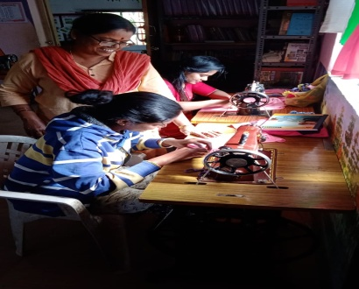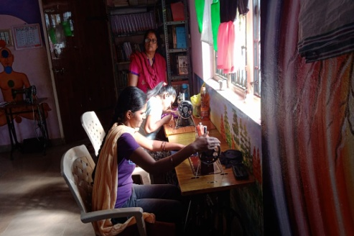
3 | Empowerment and Livelihood programs for women:  - Skill up-gradation / training of active members of SHGs in Agriculture, animal husbandry, kitchen gardening, home products etc. | Below-On 27.12.2021 Orientation sessions have been held at Chitradurga and Chincholi block on Agriculture, animal husbandry and Kitchen gardening.  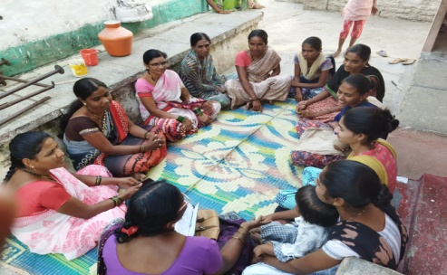
3 | - Linking with MNREGP for employment, development of rural assets, improve the socio-economic condition | 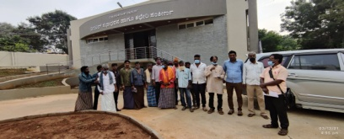  Above-Agriculture laborers and Vimukthi team meeting the Chief executive officer of ZP demanding for immediate development work on the land allotted to Sudugadu sidda nomadic of Medehalli village under MNREG  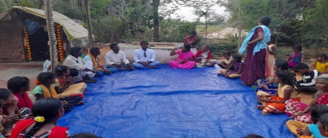  Above- Discussion with agriculture laborers at Devarahalli village on MNREG work by Vimukthi team  At Panchanapalli village, on 17.12.2021 a orientation session was held on MNREG, facilitated by PDO of Grama Panchayat and organized by Vimukthi Chincholi team.
3 | - Empowerment of newly elected Grama Panchayat women members on the Panchayt Raj Act, powers and schemes | 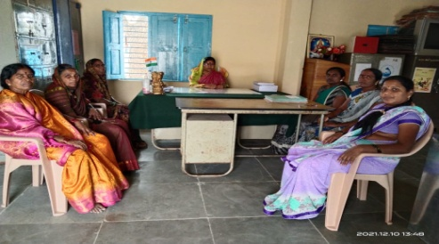  Above-Both Renuka and Sureka have met Presidents and officers of Grama Panchyat, inviting them for the newly elected GP members, to be held on 14th January 2021.
4 | Protection and preservation of eco system:  - Awareness on issues and responsibilities pertaining to Eco-system for youth in schools and colleges | 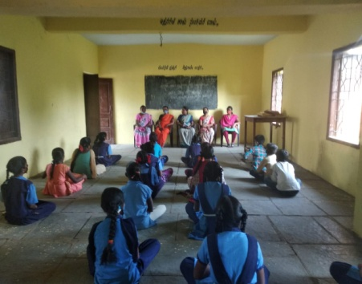  Above-In several schools and at Community level awareness on eco system have been held at Chincholi and Chitradudrga block all through the quarter.  On 07.12.2021 it was held at Huvinahalli Government school, Chincholi taluk, facilitated by Renuka and Sureka.  On 22.12.2021 awareness on Eco system was conducted at Sulepete Public school. The guests like Pampapathi Maridevaru, Head master of the school, Retired Army officer spoke on the subject. It was attended by 50 students and 6 teachers.
4 | - Strengthening the informal organic farmers forum for sustainable organic farming | 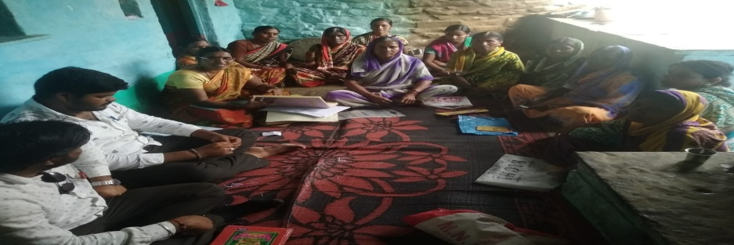  Above and below- At Chincholi block Both Renuka and Surekha have organized orientation sessions for both men and women farmers on organic farming, sustainable agriculture, and schemes with agriculture departments , twice , inviting agriculture department officers.  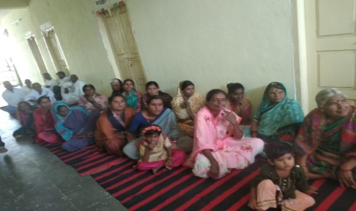  Above and below- One day training on organic farming and government schemes was held at Kupanur village on 21.12.2021 , Chincholi. The resource persons like Imran Ali, the Agriculture officer, The Vice president of GP Kupanur Mrs. Annapurna trained the farmers. About 22 farmers attended and got benefit of it.  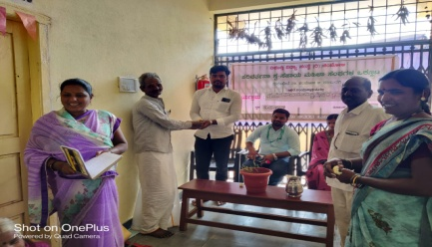
4 | - Eco –friendly activities in Dhamma land (cultivating millets, promoting eco sanctuary, child friendly environment,dhamma organic outlet | Below- Vermicompost has been promoted at Dhamma in support of OHI and local GP.  Millets , vegetables, cereals were grown and harvesting also been done as following:  - Ground nut-150 kilo  - Greengram-50 Kilo  - Pearl millet-50 kilo  - Vegetables (tomato, green chilly, brinjal etc) 100 kilo  The above production have been sold in the market and sold to Vimukthi well wishers, volunteers and Dhamma canteen. About Rs.8000-00 was collected and it is been deposited in Vimukthi General bank account  Two goats were purchased and taken care.  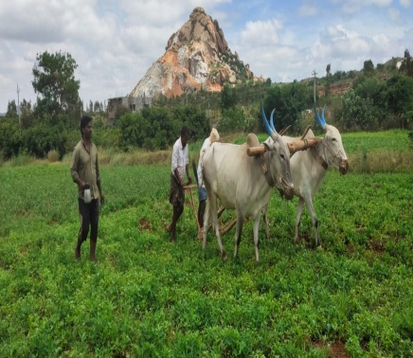  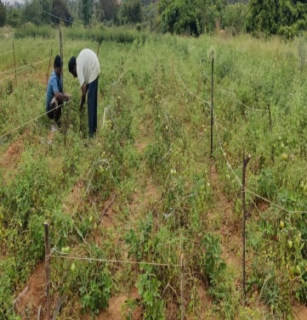
 | General  Financial statement of Self help Groups
  Name of the staff | Total SHGs | Saving during quarter | Loan distributed  During quarter | Loan returned  During quarter | Interest
  Sureka | 25 | 33500 | 116500 | 45900 | 2200
  Renuka | 13 | 49900 | 132600 | 66000 | 1400
  Kumar H | 13 | 41300 | 175000 | 273200 | 3200
  Gururaj.A | 07 | 17100 | 28500 | 76000 | 2950
  Kamala | 01 | 7800 | nill | 40000 | 1600
  Geetha | 04 | 13100 | 38000 | Nil | nil
  Total | 62 | 162700 | 465400 | 505100 | 11850

Project proposal submitted to Open Hands India-United Kingdom
for the period April 2022 to March 2023
and promgram impact of 2021-22

Working area and Rationale

- New Initiative
Over the last 3 years we have selected 4 villages and 4 slums belonging to Nomadic and semi Nomadic communities in Chitradurga district who are residing in temporary sheds over 15-20 years, without a proper house, electricity, drinking water, drainage, and other amenities. Apart from this, most of the families are engaged in rag picking, begging, fortune telling, petty business and other small occupations, which are hardly fetching any income. Over the last 2 years Vimukthi has intervened in dialoguing with the community, promoting women and men self help groups (they had never tried in the past) saving and credit activities, enrolling children to schools and hostels, conducting informal learning centers for children in evening hours with the help of volunteers ( in two places)

We are also closely working with the local government in mobilizing above facilities for the nomads and Semi Nomads. But, so for except drinking water facility for 2 villages, none of the other facilities have been ensured by the government, due to negligence and other reasons. Hence, the campaign, advocacy, lobbying needs to be continued. To a certain extended we have succeeded in enrolling 75 % of children of these families in to the mainstream schools, in the midst of pandemic. Further, we have influenced women folk from this community to form themselves in to self help groups and so for we have formed 12 self help groups, including 2 men groups and they have started savings, internal lending. As they are nomadic and living in temporary tents, none of the commercial banks are coming forward to provide bank loan, fearing that they may not repay the loan amount and moreover, they do not have adequate source of income to repay.

Hence, here is a genuine request from the groups to support them at this crucial juncture, with some revolving grants to take up petty business like buying and selling stationary materials, rearing country chicken, sheep and goats, in which they have some experience. The small amount of Rs.1000 for buying country chicken( 6 Groups x 5 persons:30 members) Rs.3000 for sheep/goat (6 groups x 5 persons:30 members) and Rs.1000 for petty business( 4 groups x 5 members:20 members) , altogether proposed for 80 women) The amount given as revolving grants to each beneficiary, will be returned over a period of 6 months to the organization, and the loan returned will be used for next batch of beneficiaries. This enables the groups to learn thrift and credit management, improve their business skill and economic condition and influence the mainstream banks and other financial institutions to come forward to provide loans and other input.

Following are the target villages and slums where Vimukthi has selected for the intervention.

Sl.no | Villages name | Caste | Category | Total Household | Population | Number of SHGs formed | Total members in the group
1 | MEDEHALLI Nomadic colony | SUDUGADUSIDDA  BUDUGA JANGAMA | SC  SC | 65 | 250 | 1 | 10
2 | N.GOWRIPURA  Nomadic colony (SC) | JOGI, Handi jogi | BCM | 174 | 783 | 0 | 0
3 | N.DEVARAHALLI  Nomadic colony (SC) | JOGIRU,HANDIJOGIYARU | BCM | 300 | 1546 | 1 | 10
4 | NAYAKANAHATTY  Nomadic colony /siddara colony/mandaru | MANDRU,DOMBI DASARU | SC  BCM | 100 | 540 | 3 | 35
 | Slums-Chitradurga
5 | Channakkihonda Nomadic Colony | Bhovi, Sillekyataru, |  | 150 | 763 | 3 | 42
 | Kelagote Nomadic colony | Handi Jogi  SHILLEKYATHA, | SC | 450 | 4020 | 1 | 13
6 | Ashraya Badavane-Malappanahatti  Nomadic colony |  |  | 125 | 625 | 1 | 10
7 | Haliyuru Railway station | Sudugadu sidda  Dombidasaru | SC | 30 | 175 | 1 | 15
8 | Chikkagondanahalli | Koracha | SC | 30 | 300 | 1 | 10
 | Total |  |  | 1264 | 8912 | 12 | 145

Proposed Programs:
Empowerment and Livelihood programs for women:
- Skill up-gradation training and revolving grants for income generation for Namodic SHGs (Chitradurga)
- Linking with MNREGP for employment, development of rural assets, improve the socio-economic condition (Chincholi)
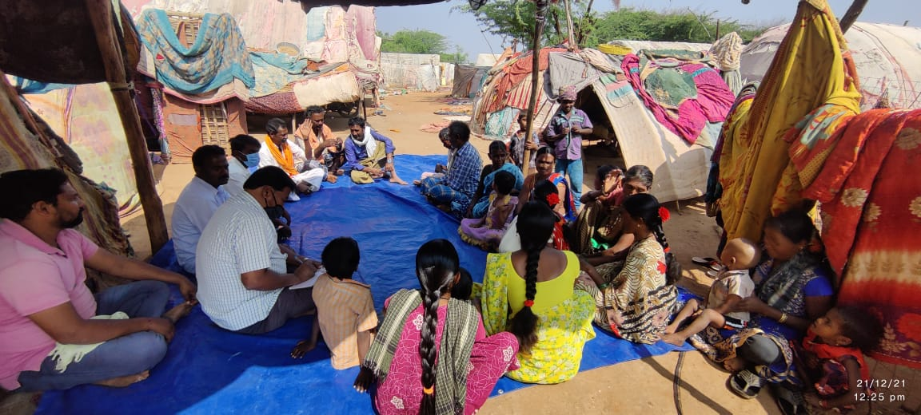

Interaction with Nomadic community at Devarahalli on their problems and occupations and interview with a member of SHG of Nomadic community at Medehalli who is doing petty business -by Gururaj. Business kit is shown by the women.
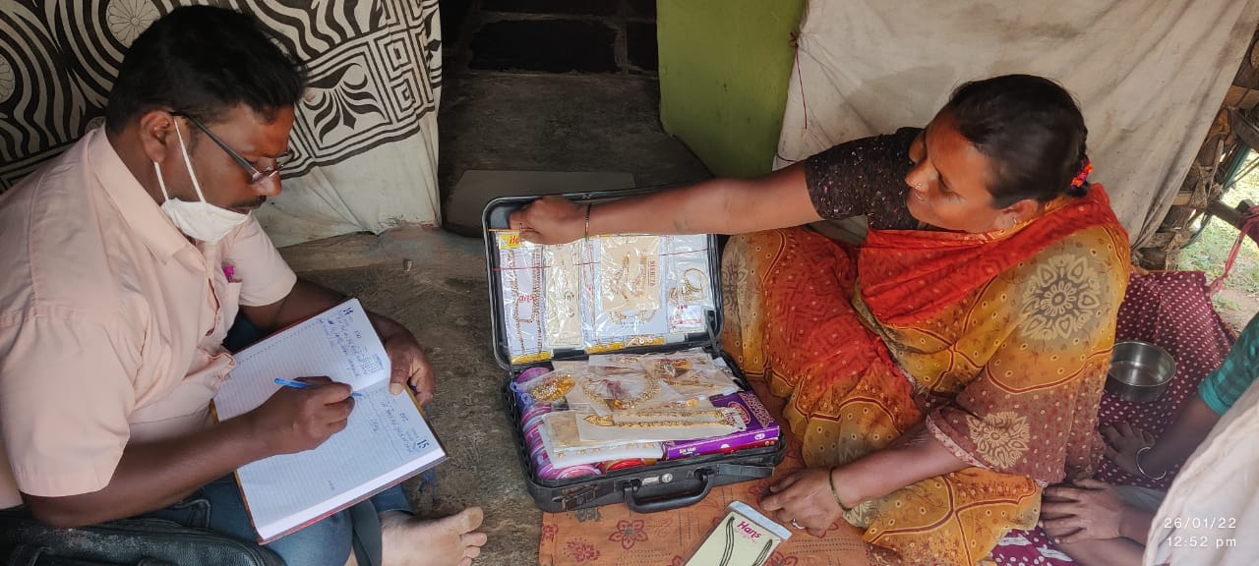

- Continuation project with Specially challenged children

There are about 94 children in Chitradurga block and 62 children in Chincholi block, who are specially challenged, including physically handicap, speech and hearing impaired, visually challenged, mentally retorted, multiple disabled and other form of disabilities.

In the previous year Vimukthui has conducted number of activities in both the clusters, and has assisted all these children in different form like , physiotherapy for multiple disabled including physically handicap, referral service for all forms of children at local and district hospitals, medical check-up and treatment camp at Dhamma in Chitradurga and at local and taluk level hospitals in both the places, distribution of Ayurveda medicines for various form of disabilities at family level and at Dhamma camp, mobilizing government facilities like handicap pensions, getting medical certificate, tricycles, scooters, enrollment to mainstream schools and special schools, counseling service to parents. All these has created a hope in the life of children, there is steady improvement in physical and mental health of the children, social acceptance in the communities.

The service and empowerment program provided by Vimukthi to specially challenged in both the clusters have been appreciated by the parents, children, communities and various government departments. Further, there is a demand from the parents and the community to continue the service and hence, the program will continue in the year 2022-23. Following is the list of village/slums and specially challenged.

Activities proposed:

Rescue and rehabilitations of children with disabilities:
  - Medical camp and referral service for poor and needy children with disabilities (Chitradurga and Chincholi)
  - Enrolling in to mainstream/special schools of children with disabilities (Chitradurga and Chincholi clustes)

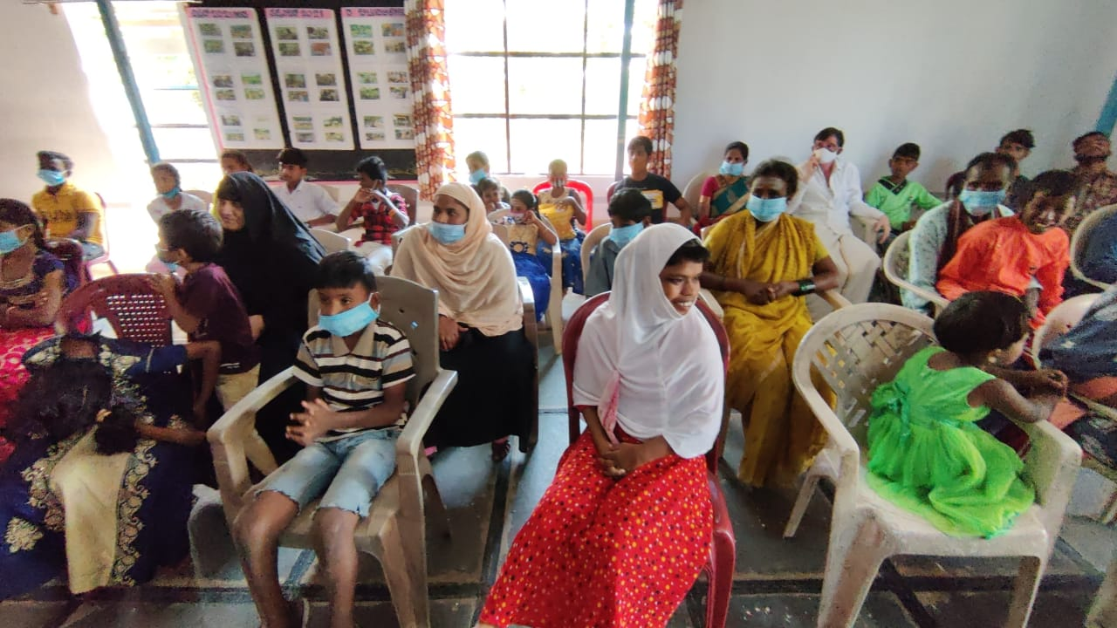

Above and below- Medical checkup camp was conducted at Chincholi block by Surekha and Renuka for disabled, old aged persons. About 45 parents got benefit by the camp. Doctors and Nurse form a government hospital, nearby attended and after diagonalization, provided medicine

. List of Disabled children in Chitradurga Clusters
1. Lakshmi sagara GP and village
1 |  |  | Kavya |  |  |  |  |  |  | 3 |  |  |  |  |  |  |  | P.H
2 |  |  | Abhishek |  |  |  |  | Shubakar |  | 11 |  |  |  |  |  |  |  | P.H
3 |  |  | Prashanth |  |  |  |  | Muthanna |  | 6 |  |  |  |  |  |  |  | P.H
4 |  |  | Immanuel |  |  |  |  |  |  | 13 |  |  |  |  |  |  |  | M.R
Village name :-2. Kyasapura
5 |  |  | Sowndarya |  |  |  |  | Mallikarjun |  | 13 |  |  |  |  |  |  |  | M.R
6 |  |  | Veeresh |  |  |  |  | Thippeswamy |  | 17 |  |  |  |  |  |  |  | M.R
7 |  |  | T.Ganesh |  |  |  |  | Thippeswamy |  | 10 |  |  |  |  |  |  |  | M.R
 |  |  | Village Name:- 3. Chikkapura gollara hatti
8 |  |  | Manoj |  |  |  |  | Kariyappa |  | 6 |  |  |  |  |  |  |  | Deaf
9 |  |  | Vijay |  |  |  |  | Nagarajappa |  | 9 |  |  |  |  |  |  |  | P.H
10 |  |  | Rakshitha |  |  |  |  | Lokesh |  | 4 |  |  |  |  |  |  |  | M.R
 |  |  | Village Name:-4. neelayanahatti
11 |  |  | Mohmmed Fayaz |  |  |  |  | Mohammed Zabi |  | 9 |  |  | 4th |  |  |  |  | Blind
12 |  |  | Musthaffa |  |  |  |  | Sheak Ahammed saab |  | 15 |  |  | 9th |  |  |  |  | P.H
 |  |  | Village Name :- 5. Vijapura Gollarahatti
13 |  |  | Renukamma |  |  |  |  | Chenna Basappa |  | 12 |  |  |  |  |  |  |  | M.R
14 |  |  | Siddesh |  |  |  |  | Madhappa |  | 14 |  |  |  |  |  |  |  | M.R
 |  |  | Village Name :-6 Vijapura
15 |  |  | Lavanya |  |  |  |  | Hanumanthappa |  | 8
16 |  |  | Bindu |  |  |  |  | Lokeshappa |  | 10
17 |  |  | Vidyashree |  |  |  |  | Anandmurthy |  | 10 |  |  | 4th |  |  |  |  | Blind
18 |  |  | Minakshamma |  |  |  |  | Thippeswamy |  | 12 |  |  | 6th |  |  |  |  | PH
19 |  |  | Akash |  |  |  |  | Rajappa |  | 11 |  |  | 5th |  |  |  |  | Blind
 |  |  | Village Name :- 7. Kitadatti
 |  |  | Village Name :- 8 Chikkapura
20 |  |  | Bharath kumar |  |  |  |  | Nagabhushan |  | 17 |  |  | 9th |  |  |  |  | Partly blind
2. Inalli Panchyat
Village Name:- 1. Chennaiyanahatti
21 | Teja bai |  |  | murthy naik |  |  |  |  | 13 |  |  |  |  | 7 |  |  |  |  | M R
22 | Dhasharatha naik |  |  | Govind naik |  |  |  |  | 17 |  |  |  |  | 6 |  |  |  |  | P.H
Village Name:-2. K. Ballekatte
23 | Nayana |  |  | Siddappa |  |  |  |  | 15 |  |  |  |  |  |  |  |  |  | MR
Village Name:-3. Beeravara
24 | Nagaraj |  |  | Tippeswamy |  |  |  |  | 16 |  |  |  |  |  |  |  |  |  | Blind
25 | Shreya |  |  | Shanrtappa |  |  |  |  | 4 |  |  |  |  |  |  |  |  |  | P.H
Village Name:-4. Malena halli
26 | Yashu |  |  | Umapathi |  |  |  |  | 3 |  |  |  |  |  |  |  |  |  | P.H
Village Name:-5. vaddanahalli
27 | Yuvaraja B |  |  | Bosaya |  |  |  |  | 6 |  |  |  |  |  |  |  |  |  | P.H
Village name:- 6. Kathral Thimappana halli
28 | Riyana |  |  | Peersab |  |  |  |  | 10 |  |  |  |  |  |  |  |  |  | P.H
29 | Kallesh Gowda |  |  | N.K.Siddesh |  |  |  |  | 6 |  |  |  |  |  |  |  |  |  | Deaf
Village Name:-7. Inahalli k hatti
30 | Anitha |  |  | Nagarajappa |  |  |  |  | 15 |  |  |  |  |  |  |  |  |  | P.H
31 | Manvith |  |  | Thippeswamy |  |  |  |  | 11 |  |  |  |  |  |  |  |  |  | P.H
 | Village Name: 8. Maragatta
32 | Mamatha |  |  | Kumaraswamy |  |  |  |  | 17 |  |  |  |  | 8th |  |  |  |  | MR
33 | Rupa |  |  | Basavarajappa |  |  |  |  | 16 |  |  |  |  |  |  |  |  |  | MR
 | Village Name : 9. Inalli
 |  |  |  | Nill
34 | Village Name: 10. N. Ballegatte
35 | Priyanka |  |  | thippeswamy |  |  |  |  | 18 |  |  |  |  | PUC |  |  |  |  | PH
3.GR Halli Panchayat
Village name:- 1. Aithol
36 |  | Swamy |  |  |  |  | Parshuramappa |  |  |  |  | 11 |  |  |  |  |  |  |  | MR
37 |  | Dhrashan |  |  |  |  | Nagappa |  |  |  |  | 12 |  |  |  |  |  |  |  | MR
Village Name:-2. Tamatakallu
38 |  | Rahul |  |  |  |  | Hanumanthappa |  |  |  |  | 3 |  |  |  |  |  |  |  |  |  | P.H
39 |  | Amrutha |  |  |  |  | Thippeswamy |  |  |  |  | 5 |  |  |  |  |  |  |  |  |  | P.H
40 |  | Murali |  |  |  |  | Murthappa |  |  |  |  | 16 |  |  |  |  |  |  |  |  |  | P.H
41 |  | Basavaraj |  |  |  |  | Murthappa |  |  |  |  | 14 |  |  |  |  |  |  |  |  |  | P.H
42 |  | Lingaraj |  |  |  |  | Thippeswamy |  |  |  |  | 2 |  |  |  |  |  |  |  |  |  | Blind
43 |  | Sakamma |  |  |  |  | Thippeswamy |  |  |  |  | 4 |  |  |  |  |  |  |  |  |  | Blind
44 |  | Yadunandana |  |  |  |  | Raja |  |  |  |  | 8 |  |  |  |  |  |  |  |  |  | P.H
45 |  | Sanjay |  |  |  |  | Kanumkka |  |  |  |  | 5 |  |  |  |  |  |  |  |  |  | P.H
46 |  | Anjanmurthy |  |  |  |  |  |  |  |  |  | 15 |  |  |  |  |  |  |  |  |  | MR
Village Name:-3. G.R Halli
47 |  | H.S. Usha |  |  |  |  | Suresh |  |  |  |  | 8 |  |  |  | 3rd |  |  |  |  |  | Dum and deaf
48 |  | R.Akash |  |  |  |  | Ramachandrappa |  |  |  |  | 7 |  |  |  | 2nd |  |  |  |  |  | Dum
49 |  | R.S. Yashawanth |  |  |  |  | Shreenivas |  |  |  |  | 11 |  |  |  | 6th |  |  |  |  |  | P.H
50 |  | B.A. Maruthi |  |  |  |  | Anjanamurthi |  |  |  |  | 12 |  |  |  | 7th |  |  |  |  |  | M.R
51 |  | C.Ajith |  |  |  |  | Channakeshawa |  |  |  |  | 11 |  |  |  | 6th |  |  |  |  |  | P.H
52 |  | S.Gurumurthi |  |  |  |  | Shreenivas |  |  |  |  | 10 |  |  |  | 5th |  |  |  |  |  | M.R
53 |  | Hariprasad |  |  |  |  | Ningaraj |  |  |  |  | 16 |  |  |  | 10th |  |  |  |  |  | P.H
54 |  | Varalakshmi T.A |  |  |  |  | Anandreddy |  |  |  |  | 15 |  |  |  | 9th |  |  |  |  |  | Multiple disabled
55 |  | Hariprasad .T.M |  |  |  |  | Manohar Reddy |  |  |  |  | 15 |  |  |  | 9th |  |  |  |  |  | Deaf and blind
56 |  | Sushmitha .R |  |  |  |  | Rudramuni |  |  |  |  | 6 |  |  |  | 1st |  |  |  |  |  | Multiple disabled
57 |  | Sandeep |  |  |  |  | Rajashker |  |  |  |  | 4 |  |  |  |  |  |  |  |  |  | P.H
58 |  | Kavya |  |  |  |  | Jagadeesh |  |  |  |  | 18 |  |  |  |  |  |  |  |  |  | M.R
4.MK.Hatti Panchayt
Village name:- MK. Hatti
Sl no | Name |  |  |  |  | Father name |  |  |  |  | Age |  |  |  |  |  | Education |  |  |  |  |  | Type of disability
59 | Chandrappa |  |  |  |  |  |  |  |  |  | 16 |  |  |  |  |  | 10th |  |  |  |  |  | Physically handicap
60 | Babu |  |  |  |  |  |  |  |  |  | 10 |  |  |  |  |  | 4th |  |  |  |  |  | Physically handicap
61 | Gopi |  |  |  |  |  |  |  |  |  | 18 |  |  |  |  |  |  |  |  |  |  |  | Physically handicap
62 | Jaiba |  |  |  |  | Jakriya, Mulsarbanu |  |  |  |  |  |  |  |  |  |  | 8105787662 |  |  |  |  |  | MR
63 | Tamkinbanu |  |  |  |  | Pirusulla , jaminabanu |  |  |  |  |  |  |  |  |  |  | 8660850510 |  |  |  |  |  | MR
64 | Manjula |  |  |  |  | Nagappa, jayamma |  |  |  |  |  |  |  |  |  |  | 9972472190 |  |  |  |  |  | Multiple
65 | Bhavani |  |  |  |  | Raghu, Gurushanthma |  |  |  |  |  |  |  |  |  |  | 8105019265 |  |  |  |  |  | MR
66 | Saraswathi |  |  |  |  | Nagendrappa |  |  |  |  |  |  |  |  |  |  | 9663941949 |  |  |  |  |  | Blind
67 | Chandan |  |  |  |  | Ramesh, Sumangala |  |  |  |  |  |  |  |  |  |  | 9964733252 |  |  |  |  |  | Blind
68 | Prathibha |  |  |  |  | Siddesh, Nagaveni |  |  |  |  | MR nagara |  |  |  |  |  | 7259619933 |  |  |  |  |  | MR
Village name:- Seebara
69 | Bhavana |  |  |  |  |  |  |  |  |  | 10 |  |  |  |  |  |  |  |  |  | Physically handicap
70 | Muttu prasanna |  |  |  |  |  |  |  |  |  | 15 |  |  |  | 7th |  |  |  |  |  | Physically handicap
71 | Ashwini |  |  |  |  |  |  |  |  |  | 15 |  |  |  |  |  |  |  |  |  | Dum and deaf
Village name:- Kodaiyanahatti
72 | Yashavanth |  |  |  |  |  |  |  |  |  | 4 |  |  |  |  |  |  |  |  |  | Multiple disabled
73 | Sanju |  |  |  |  |  |  |  |  |  | 15 |  |  |  |  |  |  |  |  |  | Multiple disabled
74 | Thippeswamy |  |  |  |  |  |  |  |  |  | 10 |  |  |  | 4th |  |  |  |  |  | Physically handicap
- Medehalli GP and village
Sl No |  |  | Name |  | Father name |  |  |  |  | age |  |  |  |  |  |  | Education |  |  |  |  |  | Type
75 |  |  | Manu |  | Manjunath |  |  |  |  | 4 |  |  |  |  |  |  |  |  |  |  |  |  | Physically H
76 |  |  | Ajay |  | Rajappa |  |  |  |  | 12 |  |  |  |  |  |  |  |  |  |  |  |  | M.R
77 |  |  | Guruprasanna |  | Umesh |  |  |  |  | 3 |  |  |  |  |  |  |  |  |  |  |  |  | Blind
78 |  |  | Joythi |  | Manjunath |  |  |  |  | 4 |  |  |  |  |  |  |  |  |  |  |  |  | M.R
79 |  |  | Chaitra |  | Chandrappa |  |  |  |  | 14 |  |  |  |  |  |  |  |  |  |  |  |  | M.R
80 |  |  | Basavaraj |  | Renukamma |  |  |  |  | 10 |  |  |  |  |  |  |  |  |  |  |  |  | M.R
81 |  |  | Shivu |  | Naganna |  |  |  |  | 18 |  |  |  |  |  |  |  |  |  |  |  |  | M.R
82 |  |  | Lakshmi |  | Thimmanna |  |  |  |  | 7 |  |  |  |  |  |  |  |  |  |  |  |  | DD
83 |  |  | Sandeep |  | Srinivas |  |  |  |  | 9 |  |  |  |  |  |  |  |  |  |  |  |  | P.H
84 |  |  | Sanjay kumar |  | Vijaykumar |  |  |  |  | 9 |  |  |  |  |  |  |  |  |  |  |  |  | Blind
85 |  |  | Basavaraj |  | Boranna |  |  |  |  | 9 |  |  |  |  |  |  |  |  |  |  |  |  | Blind
86 |  |  | Abhishek |  | Rudrappa |  |  |  |  | 9 |  |  |  |  |  |  |  |  |  |  |  |  | P.H
87 |  |  | Thippeswamy |  | Chikkirappa |  |  |  |  | 13 |  |  |  |  |  |  |  |  |  |  |  |  | Blind
88 |  |  | Parushurama |  | Gurappa |  |  |  |  | 13 |  |  |  |  |  |  |  |  |  |  |  |  | P.H
89 |  |  | Shivakumar |  | Nagarajappa |  |  |  |  | 13 |  |  |  |  |  |  |  |  |  |  |  |  | M.R
90 |  |  | Ningesh |  | Thippeswamy |  |  |  |  | 17 |  |  |  |  |  |  |  |  |  |  |  |  | P.H
91 |  |  | Shivakumar |  | Thippeswamy |  |  |  |  | 16 |  |  |  |  |  |  |  |  |  |  |  |  | Blind
92 |  |  | Kantharaj |  | Jagappa |  |  |  |  | 15 |  |  |  |  |  |  |  |  |  |  |  |  | Blind
93 |  |  | Siddesh |  | Trimurthy |  |  |  |  | 7 |  |  |  |  |  |  |  |  |  |  |  |  | Blind
94 |  |  | Manjunath |  | Shivanna |  |  |  |  | 18 |  |  |  |  |  |  |  |  |  |  |  |  | P.H

Consolidated list
Sex | Visually challenged | Mentally retorted | Speech and hearing impaired | Physically handicap | Multiple  Disabled | Total
Male | 14 | 13 | 2 | 27 | 3 | 59
Female | 4 | 12 | 3 | 14 | 2 | 35
Total | 18 | 25 | 5 | 41 | 5 | 94

List of specially challenged children of Chincholi block is yet to be finalized.

- Health, education and skill empowerment of youth (teen age girls):
As per our experience, 50 % of girls at schools level and 75 % at Pre-university level are dropping out from studies, due to fail in exams, lack of support from parents for higher studies, child marriage and lack of knowledge on career guidance (not knowing what subject/course that they could opt after 10th or 12th standard. Hence, empowerment, Career guidance and counseling to Girls of 10th, 11th, 12th standard is essential.
Further, a majority of girls, particularly from poor socio-economic situation are facing various kinds’ of psychological and physical problems, which are a hinder in their career and social life. Due to rigid social and religious customs and practices, majority of girls are not given orientation/training on personal hygiene and as a result, they are at a risk, facing various kinds of stress and diseases.
During the year 2021-22 we have conducted career guidance for 50 girls in Chitradurga, at Dhamma and personal hygiene training in 10 schools in Chitradurga and 10 schools in Chincholi with the help of external resource persons and local health educator and Vimukthi women staff. This has contributed a lot in the life of teen age girls and there is a demand for the continuation.
This year we have come up with training materials like audio, video and training manual on career guidance and personal hygiene. We propose to undertake these activities in selected schools and colleges, as listed below:

Proposed programs:
- Health education and personal counseling on personal hygiene for teen age girls (in Schools and PU colleges)
- Career guidance to continue higher education to acquire adequate knowledge on right education.
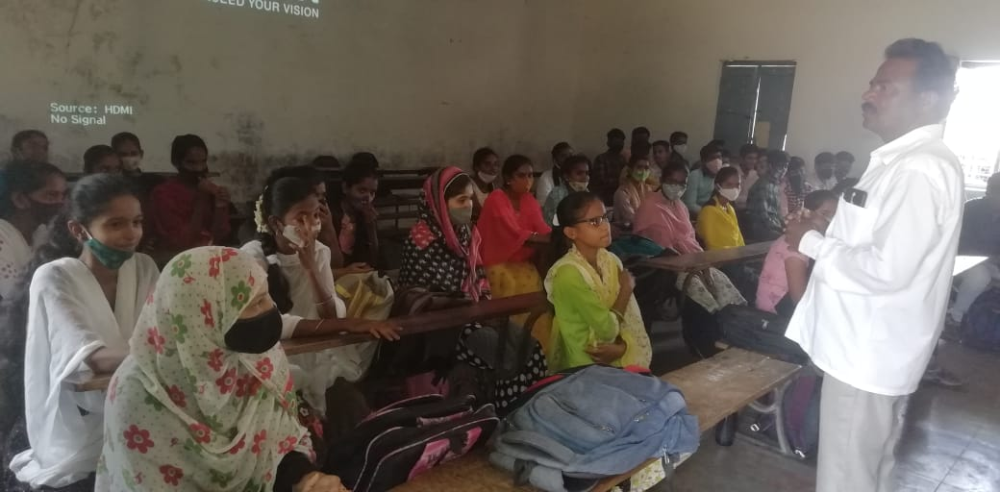
Above photo -Career guidance at Nayakanahatti school by Field staff Mr. Maripalaiah and Personal hygiene training to teen girls by Health educator and Vimukthi Volunteer Arpitha, below photo
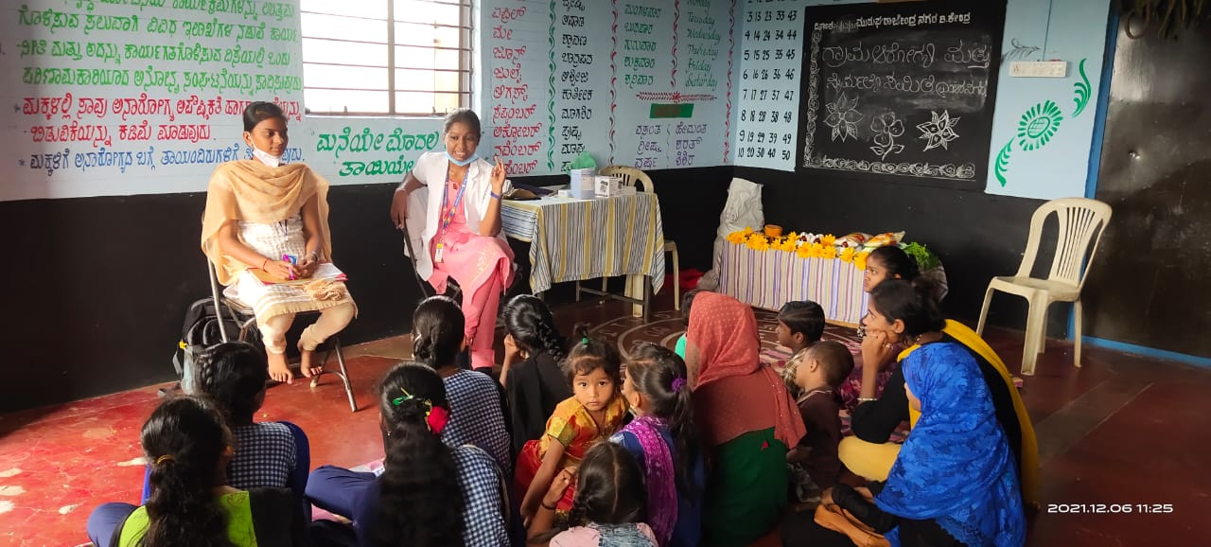
Proposed schools and colleges for the career guidance and personal hygiene for 2022-23
SI.NO | Name of the government and aided school and PU College in Chitradurga block | Place
1 | Shabara shankara residential high school | Vijapura
2 | Govt. High school | Lakshmi sagara
3 | Netaji residential high school | Kyasapura
4 | Murarji residential high school | Gulaiahnahatti
5 | Govt. High school | Ainalli kurubara hatti
6 | Murarji residentcial high school | Kodirangavvana halli
7 | Rock fort High school | MK Hatti
8 | Government High school | Hirekabbagere Gollarahatti
9 | Government high school and PU college | Chikkgondanahalli
10 | Government High school | Muddapura
11 | Vishwa manava residential High school and PU college | Gutthinadu
12 | Muraraj residential school | Seebara
13 | Rama Krishna High school | MK Hatti
14 | Priyadarshini Girls High school | MK Hatti
15 | Murarji residential High school | Medehalli
16 | Govt. High school | GR Halli
17 | Sri Anjaneya Swamy Rural High School | Tamatakallu
18 | Sri Guru thippeswamy Rural High school | Nayakanahatti
19 | Hatti Mallappa Nayaka High school | Nayakanahatti
20 | Govt. High School | Devarahalli
21 | Kannada Vijaya High School | Manamaiahanahatti
List of schools to be covered in Chincholi block
1 | Govt High school | Sulepete
2 | Govt urdu High school | Sulepete
3 | Govt PU college | Sulepete
4 | Govt Degree College | Sulepete
5 | Jeevana Sadhana High school | Sulepete
6 | Gurunanjeshwara High School | Sulepete
7 | Govt High School | Hoovinabavi
8 | Govt High School | Garagapalli

- Protection and preservation of eco system:
Dhamma eco sanctuary has become a learning centre for schools and college students, members of SHGs, Agriculture departments, Grama panchyat, NGOs, Universities. Hundreds of people have visited in the past, attended training at Dhamma and have experienced the eco sanctuary created and have gone back with lots of hopes, inspiration and commitment.
Here in Dhamma thousands of different plants, hundreds of domestic and wild animals and birds have taken shelter and are living in harmony, agriculture pond, stream, Vermicompost, millet plats, meditation centre are the centre of attraction and learning on organic and sustainable agriculture, horticulture, preservation and protection of land, water, plants and animals.
During the project period, Vimukthi both in Chitradurga and Chincholi has conducted training/orientations in schools and community on protection of eco system, promotion of organic farming, production and consumption of millets and so on.
We propose to continue the following activities for the year 2022-23 as following:
- Awareness on issues and responsibilities pertaining to Eco-system for youth in schools, colleges and communities.
- Eco –friendly activities on Dhamma land (cultivating fruit and forest plants, improving fertility of the land, bore well re-charge, caring and rearing domestic and wild animals and birds, and other related)

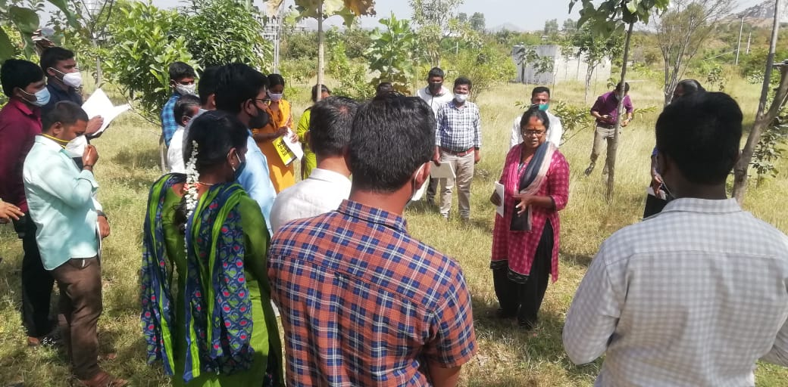

Mrs. Annapurna sharing on Dhamma eco-sanctuary with University students who had come for a field exposure.

Vimukthi through Parivarthana SHG Federation is functioning in 21 villages in Chincholi Block, with the help of OHI –UK as following:

SL No | Village name | No | Village name
Villages covered by Renuka | - Nidagunda  - Penchanapalli  - Karchakheda  - Hoovinahalli  - Ponthagal  - Halakoda  - Jattooru  - Korandapalli | Villages covered by Surekha | - Sulepete  - Pasthapura  - Yelakapalli  - Pasthapura Thaanda  - Chimmaidalayi  - Chincholi  - Paradara Mothakapalli  - Rustampura  - Kupanooru  - BeeranaHalli  - Koravi  - Koravi Thaanda  - BedakaPalli
Following villages are covered by Ex-Vimukthi staff who left the organization due to their personal reasons, but , are continuing to work with SHGs
Villages covered by Ex staff Sunitha | - Nidagunda  - Shirolli  - Rudnooru  - Karchakheda  - Halakhoda  - Pothangal | Villages covered by EX staff Lakshmi | - Chimmanachoda  - Nagaraala  - Naranaala  - HasaraGundigi  - Dottikolla  - Khudavanda Pura  - Khudampura  - Sasaragaava

Vishwa Sagar.R
Director
Vimukthi Vidya Samsthe

